

Requirement & Design Specification

**House Rental Management System (HRMS)**

**Version: 2.0**

| **<SWP391_G2>** | |
| --- | --- |
| **Group Members** | **Hà Quang Thắng - HE176429- ThangHQHE176429@fpt.edu.vn**  **Phạm Văn Tiến - HE163824- TienPVHE163824@fpt.edu.vn**  **Nguyễn Tuấn Anh - HE176694 - AnhNTHE176694@fpt.edu.vn**  **Trương Tiến Sỹ - HE176623 - SyTTHE176623@fpt.edu.vn**  **Nguyễn Bá Khánh - HE170920 - KhanhNBHE170920@fpt.edu.vn**  **Dương Thanh Tùng - HE176669 - TungTDHE176669@fpt.edu.vn** |
| **Supervisor** | **Trần Đình Trí** |

– Hanoi, September 2023 –

# Record of Changes

| **Version** | **Date** | **A* M, D** | **In charge** | **Change Description** |
| --- | --- | --- | --- | --- |
| V1.0 | 16/9 | A, M | ThangHQ, TungDT,  KhanhNB | Create new, Modify document information, Overview and Requirement Specifications section |
| V1.1 | 17/9 | M | All team members | Modify document information, Overview, Requirement Specifications, Design Specifications and Appendix section |
| V1.2 | 18/9 | M | TungDT, SyTT, AnhNT, KhanhNB | Modify document information, Overview, Requirement Specifications and Appendix section |
| V1.3 | 19/9 | M | TungDT, SyTT, AnhNT, KhanhNB | Modify Overview, Requirement Specifications, Design Specifications and Appendix section |
| V1.4 | 20/9 | M | TungDT, SyTT | Modify Overview, Design Specifications and Appendix section |
| V1.5 | 21/9 | M | TungDT, SyTT | Modify Overview and Appendix section |
| V1.6 | 22/9 | M | TungDT, SyTT, KhanhNB | Modify Overview, Design Specifications and Appendix section |
| V1.7 | 23/9 | M | TungDT, | Modify Appendix section |
| V1.8 | 24/9 | M | TungDT, TienPV | Modify Design Specifications and Appendix section |
| V1.9 | 25/9 | M | ThangHQ, TungDT,  SyTT, KhanhNB | Modify Overview, Requirement Specifications, Design Specifications and Appendix section |
| V1.10 | 26/9 | M | TungDT, SyTT | Modify document information and Overview section |
| V1.11 | 27/9 | M | SyTT | Modify Overview section |
| V1.12 | 30/9 | M | ThangHQ, TungDT,  KhanhNB | Modify Overview, Requirement Specifications and Design Specifications section |
| V1.13 | 1/10 | M | All team members | Modify Overview, Requirement Specifications, Design Specifications and Appendix section |
| V1.14 | 15/10 | M | SyTT | Modify document information |
| V1.15 | 17/10 | M | ThangHQ | Modify document information |
| V1.16 | 30/10 | M | ThangHQ, TungDT | Modify Overview and Requirement Specifications section |
| V1.17 | 31/10 | M | ThangHQ, KhanhNB | Modify Requirement Specifications and Design Specifications section |
| V1.18 | 1/11 | M | ThangHQ, TungDT, SyTT, KhanhNB | Modify Requirement Specifications, Design Specifications and Appendix section |
| V1.19 | 2/11 | M | ThangHQ, TungDT | Modify Requirement Specifications and Design Specifications section |
| V1.20 | 3/11 | M | TungDT, SyTT, AnhNT, KhanhNB | Modify Overview, Requirement Specifications and Design Specifications section |
| V1.21 | 4/11 | M | All team members | Modify Overview, Requirement Specifications and Design Specifications section |
| V2.0 | 5/11 | M | All team members | Rearrange sections, finish the document |

Contents

Record of Changes 3

I. Overview 8

1. User Requirements 8

1.1 Actors 8

1.2 Use Cases 8

2. Overall Functionalities 12

2.1 Screens Flow 12

2.2 Screen Descriptions 14

2.3 Screen Authorization 15

2.4 Non-UI Functions 16

3. System High Level Design 16

3.1 Database Design 16

3.2 Code Packages 18

II. Requirement Specifications 20

1. Login 20

1.1 UC01_Login 20

2. Logout 22

2.1 UC02_Logout 22

3. Register 23

3.1 UC03_Register 23

4. Password Retrievement 24

4.1 UC04_Forgot_Password 24

5. Account management 25

5.1 UC05_Change password 25

6. Profile management 27

6.1 UC06_Update profile 27

6.2 UC07_Upload User Avatar 27

7. Search post 28

7.1 UC08_Search post 28

8. View post list 29

8.1 UC09_View post list 29

9. Home Page 30

9.1 UC10_View Home page 30

10. View Post Detail 31

10.1 UC11_View post detail 31

11. Rating and reviews 31

11.1 UC12_Vote for post 31

11.2 UC13_Comment for post 32

12. Wishlist 33

12.1 UC14_Add to wishlist 33

a. Functionalities 33

12.2 UC15_View wish list 34

a. Functionalities 34

12.3 UC16_Remove from wishlist 35

a. Functionalities 35

13. Manage Order 36

13.1 UC17_ Create an order 36

13.2 UC18_Cancel order 36

13.3 UC19_View tenant’s orders 37

14. Landlord Profile View 38

14.1 UC20_View landlord’s profile 38

15. System Report 39

15.1 UC21_Process Report 39

15.2 UC22_Send Report 40

15.3 UC23_View Report 40

15.4 UC24_Cancel Report 41

16. Post Management 42

16.1 UC25_Publish new post 42

16.2 UC26_Update a post 43

16.3 UC27_Remove a post 43

16.4 UC28_Hide a post 44

16.5 UC29_View all personal post 45

16.6 UC30_Pay for post 46

17. User Account Manipulation 47

17.1 UC31_Add account 47

17.2 UC32_Update account 48

17.3 UC33_Disable account 49

17.4 UC34_Ban account 49

17.5 UC35_Unban account 51

17.6 UC36_View all account 51

18. Order management 52

18.1 UC37_View landlord’s orders 52

18.2 UC38_Process Order 53

19. Point Management 54

19.1 UC39_Add point to landlord 54

19.2 UC40_View transaction history 55

20. Tenant Profile View 56

20.1 UC41_View tenant profile 56

21. Promotion Management 57

21.1 UC42_Update promotion 57

21.2 UC43_Create promotion 58

21.3 UC44_Remove Promotion 59

21.4 UC45_View Promotion 59

21.5 UC46_Update promotion duration 60

III. Design Specifications 61

1. Login 58

1.1 Login 58

2. Logout 60

2.1 Logout 60

3. Register 61

3.1 Register 61

4. Password Retrievement 63

4.1 Forgot password 63

5. Account management 64

5.1 Update personal password 63

6. Profile management 66

6.1 Update profile 67

6.2 Upload user avatar 68

7. Search Post 69

7.1 Search post 69

8. View Post List 70

8.1 View post list 71

9. View Home Page 72

9.1 View home page 73

10. View Post Detail 75

11. Rating and reviews 76

11.1 Vote for post 76

11.2 Comment for room 77

12. Wishlist 78

12.1 Add to Wishlist 78

12.2 View wishlist 79

12.3 Remove from wishlist 79

13. Manage Order 83

13.1 View Order 83

13.2 Manage Order 84

13.3 System Access 84

14. Landlord Profile View 85

14.1 View landlord's profile 85

15. System Report 87

15.1 Process report 87

15.2 Send report 88

15.3 View report and cancel report 89

16. Post Management 90

16.1 Manage Post 90

16.2 Pay Post 91

16.3 Manage Post services 92

17. User Account Manipulation 93

17.1 Add account 93

17.2 Update Account 95

17.3 Disable Account 96

17.4 Ban Account 97

17.5 Unban Account 99

17.6. View all account 100

18. Point Management 102

18.1 Add Point to landlord 102

18.2 View transaction history 103

19. Tenant Profile View 104

19.1 View tenant profile 104

20. Promotion Management 105

20.1 Create a promotion 105

20.2 Edit promotion 106

20.3 Remove promotion 107

20.4 Set promotion duration 107

IV. Appendix 108

1. Assumptions & Dependencies 108

2. Limitations & Exclusions 109

3. Business Rules 109

# I. Overview

## 1. User Requirements

### 1.1 Actors

| **#** | **Actor** | **Description** |
| --- | --- | --- |
| 1 | Admin | Responsible for coordinating and controlling posts and accounts |
| 2 | Landlord | An entity that owns real estate, and then leases the property to another party for rent. |
| 3 | Tenant | Customers who pay for rental services or renters looking for housing that have an account |
| 4 | Registered Users | An abstract actor that represents Landlord or Tenant, performing common actions to Landlord or Tenant. |
| 5 | Guest | People who visit website who don’t have account in the system |

### 1.2 Use Cases

#### a. Diagram(s)

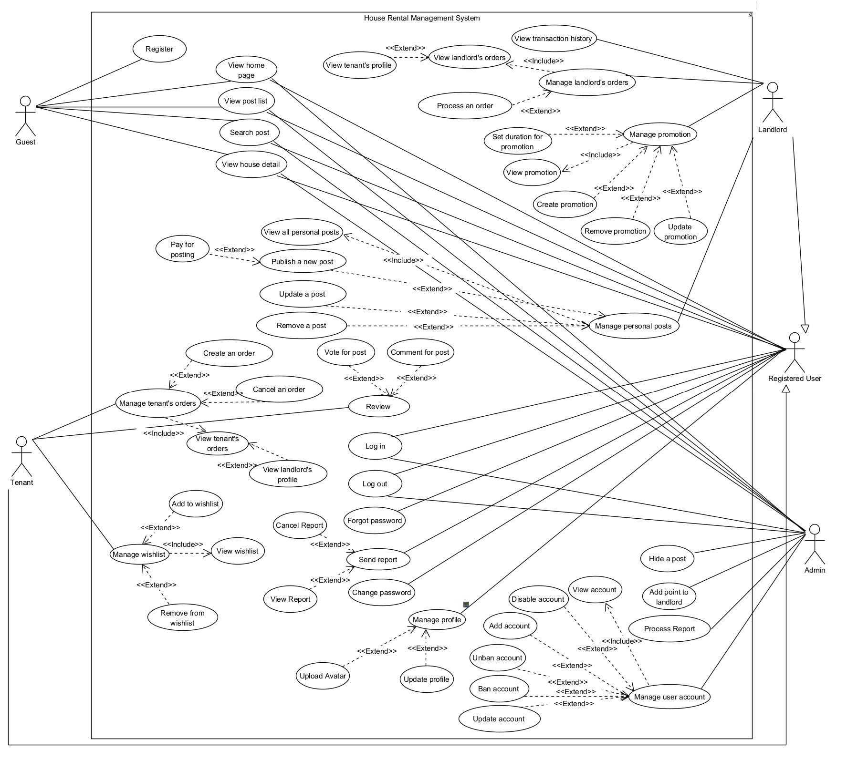

#### b. Descriptions

| **id** | **Feature** | **Use case** | **Use case description** |
| --- | --- | --- | --- |
| 1 | Login | Login | Allows users to verify their identity and access registered systems or applications. |
| 2 | Logout | Logout | Allows Tenant, Landlord and Admin to log out of the system or application, ending the current session. |
| 3 | Register | Register | Allows users to create new personal accounts on the system. |
| 4 | Password Retrievement | Forgot password | Allows users to reset their password when they forget their old password |
| 5 | Account management | Change password | Allows users to change personal password to enhance account security |
| 6 | Profile management | Update profile | Allows users to update public personal information in account information. |
| 7 | Profile management | Upload user avatar | Allow tenants and landlords to upload customized avatar |
| 8 | Search post | Search post | Allows user to enter search string and other criteria into search box to search for houses |
| 9 | View post list | View post list | Allows users to access detailed information and media for rental properties, aiding their decision-making process |
| 10 | View home page | View home page | Allows users to access the main interface, providing an overview and access to various features. |
| 11 | View post detail | View house detail | Allow users to access comprehensive information, including photos and specs, for a specific rental property. |
| 12 | Rating and review | Vote for post | Allows tenants to provide a score rating for their housing experience. |
| 13 | Rating and review | Comment for post | Allows tenants to add comments or feedback to a rental property listing. |
| 14 | Wishlist | Add to wishlist | Allows tenants to save properties they're interested in to a wishlist for future reference. |
| 15 | Wishlist | View wishlist | Allows tenants to view all property they have been added to wishlist, optionally navigate to them or delete from wishlist |
| 16 | Wishlist | Remove from Wishlist | Allow tenants to remove a post from their wishlist |
| 17 | Manage tenant's orders | Create an order | Allows tenants to initiate the process of renting a property they have selected. |
| 18 | Manage tenant's orders | Cancel an order | Allows tenants to remove a rental order they no longer wish to pursue. |
| 19 | Manage tenant's orders | View tenant's orders | Allow tenants to review their past rental orders. |
| 20 | View landlord's profile | View landlord's profile | Allows tenants access comprehensive data about the landlord when the landlord approves their rental order. |
| 21 | System Report | Process report | Allows administrators to change status of reported issues or claims, indicating the issues have been resolved. |
| 22 | System Report | Send report | Allows tenants and landlords to document and report issues encountered when using the system, such as user, system, etc. |
| 23 | System Report | View Report | Allow tenants and landlords to view their reports and their status. |
| 24 | System Report | Cancel report | Allow tenants and landlords to cancel their sent reports. |
| 25 | Post management | Publish new post | Allows landlords to input property specifics, adds high-quality images, sets rent details, and publishes a compelling listing for potential tenants to view. |
| 26 | Post management | Update a post | Allow the landlord selects a rental post to update, edits property information, and saves changes to keep the listing current. |
| 27 | Post management | Remove personal post | Allow landlord selects a rental post for removal, confirms deletion, and removes the listing from the platform. |
| 28 | Post management | Hide a post | Allows administrators to hide a post, ensuring compliance with guidelines or addressing inappropriate posts |
| 29 | Post management | View all personal posts | Allow landlords to view all their posts in one place. |
|  | Post management | Pay for post | Allow landlords to make payment for posts. |
| 31 | User account manipulation | Add account | Allows administrators to generate a tenant/landlord/admin account. |
| 32 | User account manipulation | Update account | Allows administrators to modify account information or permissions for a particular user. |
| 33 | User account manipulation | Disable account | Allows administrators to change the active or inactive status of a user account. |
| 34 | User account manipulation | Ban account | Allow administrators to ban an account |
| 35 | User account manipulation | Unban account | Allow administrators to unban an account |
| 36 | User account manipulation | View all account | Allow administrators to view all registered account |
| 37 | Order management | View landlord's orders | Allows landlords access a list of pending orders from tenants that require their attention and action. |
| 38 | Order management | Process an order (Approve/Reject) | Allows landlords to change the status of a rental order that has been approved. |
| 39 | Point management | Add point to landlord | Allows admin to add points to landlord accounts. |
| 40 | Point management | View transaction history | Allows landlords to view all their transaction history, including deposit and post payment |
| 41 | Tenant Profile Access | View tenant's profile | Allows landlords to access tenant details, including personal information, and contact information. |
| 42 | Promotion management | Update promotion | Allow landlords to update a new promotional offer, such as reduced rent or incentives, to attract potential tenants to their rental listing. |
| 43 | Promotion management | Create a promotion | Allows landlords to initiate a new promotional campaign, specifying details like discounts, incentives, or special offers to attract prospective tenants. |
| 44 | Promotion management | Remove promotion | Allows landlords select an active promotion, confirms removal, and removes it from the rental listing to end the promotional offer. |
| 45 | Promotion management | View promotion | Allows landlords to view all active promotions. |
| 46 | Promotion management | Update duration of promotion | Allow landlord to update the duration of a promotion item. |

## 2. Overall Functionalities

### 2.1 Screens Flow

### 2.1.A Screens Flow for Tenant

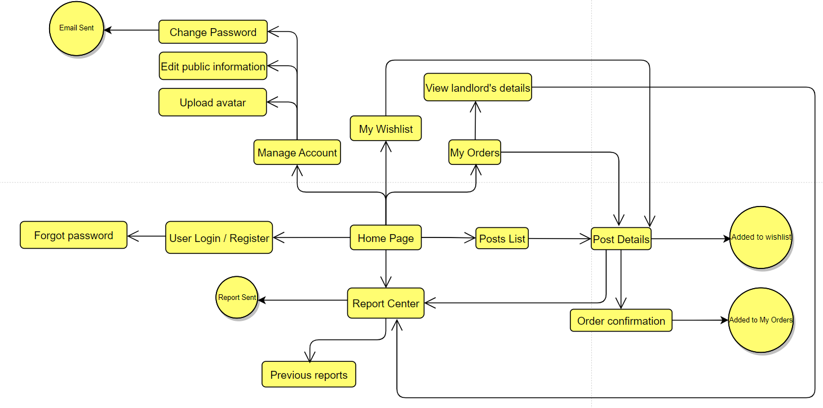

### 2.1.B Screens Flow for Landlord

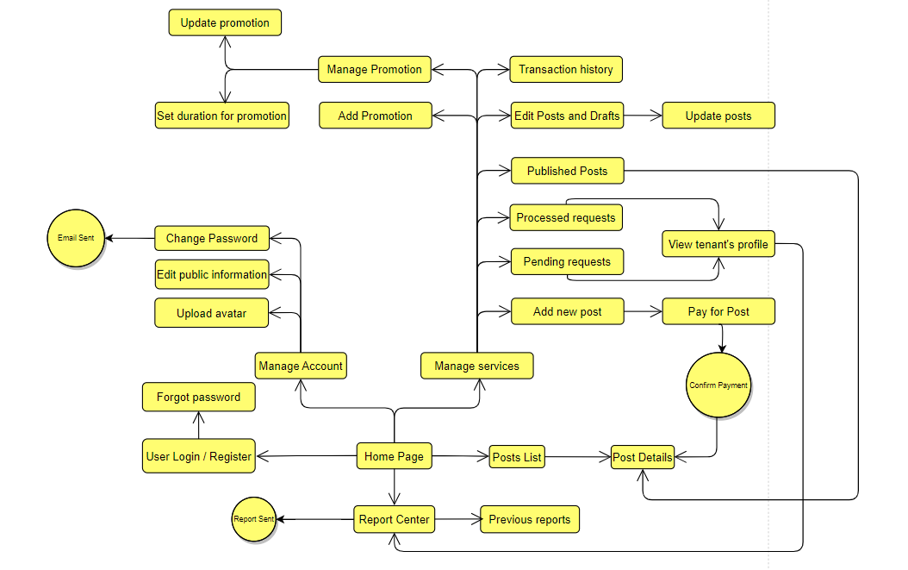

### 2.1.C Screens Flow for Admin

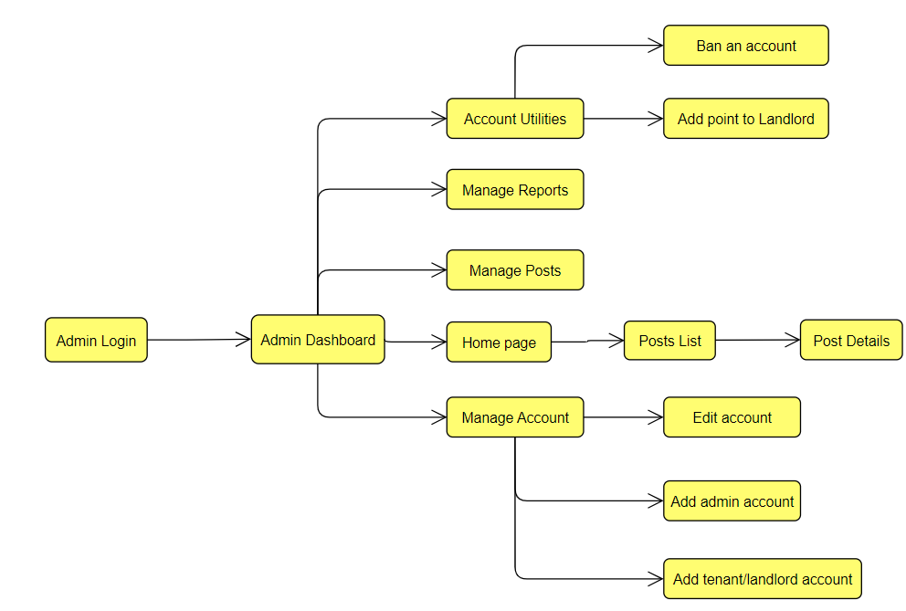

### 2.2 Screen Descriptions

| **#** | **Feature** | **Screen** | **Description** |
| --- | --- | --- | --- |
| 1 | General Display | Home Page | Screen for initial web page accessing. |
| 2 | Login and Register | User Login / Register | Screen for inputting username and password for user authentication / inputting information for registering new user |
| 3 | Forgot password | Forgot password | Screen for entering email to send the new password to the mail. |
| 4 | Posts View | Posts List | View all rental posts. |
| 5 | Post View | Post Details | View details of a single post. |
| 6 | Account Service Dashboard | Manage Account | View personal profile, and services for updating. |
| 7 | Profile Management | Edit public information | Change a user’s personal information, linked credentials,... |
| 8 | Profile Management | Upload avatar | Choosing image to upload to the profile |
| 9 | Account Management | Change password | Screen for entering old password to validate the request of changing the account’s password |
| 10 | Account Management | Email Sent | Pop-up screen announces that the request of changing password is validated, user can be redirected to Home Page |
| 11 | Report System | Report Center | Report a tenant/a property, a system bug, payment problems, … |
| 12 | Report System | Previous reports | View previously made report to the admin |
| 13 | Report System | Report Sent | Pop-up window announces that the report has successfully been sent to the admin. |
|  |  |  |  |
| 14 | Wishlist | My wishlist | View list of all posts added to the wishlist, plus the delete from wishlist button |
| 15 | Wishlist | Added to wishlist | Pop-up window announces that the post has been added to the wishlist. |
| 16 | View Orders of Tenant | My Orders | View list of orders for Tenants. |
| 17 | View Landlord’s Profile | View landlord’s details | View the landlord’s profile after the order has been approved by the landlord. |
| 18 | Order Making | Order confirmation | Screen for relevant information of the order for the tenant to view and choose to confirm the order. |
| 19 | Order Making | Added to My Orders | Pop-up window announces that order has been submitted |
|  |  |  |  |
| 20 | Landlord Dashboard | Manage services | Dashboard for landlord to manage their services |
| 21 | Post Management | Add new post | Add relevant information about a new post. |
| 22 | Post payment | Pay for Post | Payment screen for each post added. |
| 23 | Post payment | Confirm Payment | Pop-up window for the landlord to confirm their payment. |
| 24 | Transactions view | Transaction History | View list of past transactions. |
| 25 | Order Management | Pending Requests | Screen for landlords to view their list of pending orders made by clients. |
| 26 | Order Management | Processed Requests | Screen for landlords to view their list of orders made by clients that have been approved/rejected. |
| 27 | View Tenant’s Profile | View tenant’s profile | View the tenant’s profile after the order has been placed by the tenant. |
| 28 | Post Management | Published Post | List of posts published by the landlord |
| 29 | Post Management | Edit Posts and Drafts | List of all posts saved, and editing options |
| 30 | Post Management | Update Posts | Landlords can edit a post, a draft, or choose to publish the drafts by payment. |
| 31 | Post Promotion Management | Manage Promotion | List of all promotion items, and editing options. |
| 32 | Post Promotion Management | Add Promotion | Screen for inputting information of a new promotion item |
| 33 | Post Promotion Management | Update promotion | Updating the information of a current promotion item. |
| 34 | Post Promotion Management | Set duration for promotion | Set the duration for a promotion item |
|  |  |  |  |
| 35 | Admin Login | Admin Login | Login Screen for administrators |
| 36 | Admin Dashboard | Admin Dashboard | All services for the administrators. |
| 37 | User Management | Manage Account | List of all account and editing options. |
| 38 | User Management | Edit Account | Screen for Administrators to edit user’s account information |
| 39 | Post Management(Admin) | Manage Posts (Admin) | List of all current posted posts and the delete option (by force). |
| 40 | Report Management | Manage Reports | List of all reports made by users, and the option to set status for each report. |
| 41 | Account Addition | Add Admin Account | Screen for Administrators to add another administrator account |
| 42 | Account Addition | Add Tenant / Landlord Account | Screen for Administrators to add another tenant or landlord account |
| 43 | Account Management | Account Utilities | Screen for Administrators with choices of ban/unban account, and Point addition to Landlords. |
| 44 | User Management | Ban an account | Information of a user, and the combo-box for choosing the duration of the ban. |
| 45 | Point Addition for Landlords | Add point to Landlord | Show the current balance of the landlord and the option of inputting the transferred amount of points |

### 

### 2.3 Screen Authorization

| **#** | **Screen** | **Admin** | **Landlord** | **Tenant** | **Guest** |
| --- | --- | --- | --- | --- | --- |
| 1 | Home Page | X | X | X | X |
| 2 | User Login / Register |  | X | X |  |
| 3 | Forgot password |  | X | X |  |
| 4 | Posts List | X | X | X | X |
| 5 | Post Details | X | X | X | X |
| 6 | Manage Account |  | X | X |  |
| 7 | Edit public information |  | X | X |  |
| 8 | Upload avatar |  | X | X |  |
| 9 | Change password |  | X | X |  |
| 10 | Email Sent |  | X | X |  |
| 11 | Report Center |  | X | X |  |
| 12 | Previous reports |  | X | X |  |
| 13 | Report Sent |  | X | X |  |
| 14 | My wishlist |  |  | X |  |
| 15 | Added to wishlist |  |  | X |  |
| 16 | My Orders |  |  | X |  |
| 17 | View landlord’s details |  |  | X |  |
| 18 | Order confirmation |  |  | X |  |
| 19 | Added to My Orders |  |  | X |  |
| 20 | Manage services |  | X |  |  |
| 21 | Add new post |  | X |  |  |
| 22 | Pay for Post |  | X |  |  |
| 23 | Confirm Payment |  | X |  |  |
| 24 | Transaction History |  | X |  |  |
| 25 | Pending Requests |  | X |  |  |
| 26 | Processed Requests |  | X |  |  |
| 27 | View tenant’s profile |  | X |  |  |
| 28 | Published Post |  | X |  |  |
| 29 | Edit Posts and Drafts |  | X |  |  |
| 30 | Update Posts |  | X |  |  |
| 31 | Manage Promotion |  | X |  |  |
| 32 | Add Promotion |  | X |  |  |
| 33 | Update promotion |  | X |  |  |
| 34 | Set duration for promotion |  | X |  |  |
| 35 | Admin Login | X |  |  |  |
| 36 | Admin Dashboard | X |  |  |  |
| 37 | Manage Account | X |  |  |  |
| 38 | Edit Account | X |  |  |  |
| 39 | Manage Posts (Admin) | X |  |  |  |
| 40 | Manage Reports | X |  |  |  |
| 41 | Add Admin Account | X |  |  |  |
| 42 | Add Tenant / Landlord Account | X |  |  |  |
| 43 | Account Utilities | X |  |  |  |
| 44 | Ban an account | X |  |  |  |
| 45 | Add point to Landlord | X |  |  |  |

### 2.4 Non-UI Functions

| **#** | **Feature** | **System Function** | **Description** |
| --- | --- | --- | --- |
| 1 | Login | **User Authorization** | This function determines what permissions a user has after they are authenticated. |
| 2 | Login | **Session Management** | After a user logged in, a new session will be created for that user to track for information. |
| 3 | View | **Database Interaction** | Website will connect to a database to display and retrieve data |
| 4 | Login / Register | **Data Encryption** | All password will be encrypt using SHA-512 algorithm |
| 5 | Email Verification | **Email Sending** | When register a new account for forgot password, a email with token will be sent to email address |
| 6 | View | **URL Routing** | This function directs the website’s traffic to the correct page based on the URL. |

## 3. System High Level Design

### 3.1 Database Design

#### a. Database Schema

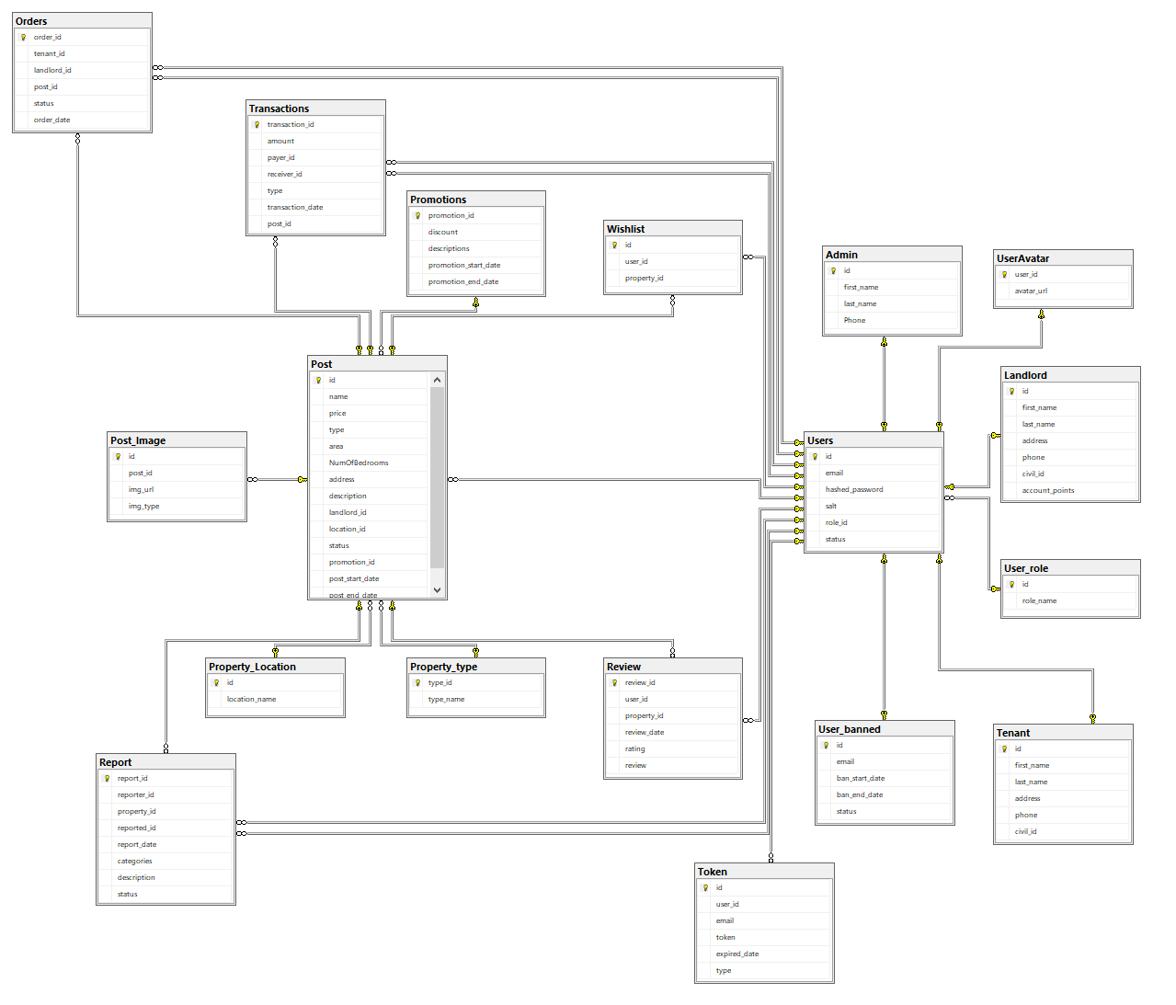

#### b. Table Descriptions

| **No** | **Table** | **Description** |
| --- | --- | --- |
| *01* | *Users* | *Stores accounts of every user in the system.*  *- Primary keys: id*  *- No FK.* |
| *02* | *Admin* | *Stores Admin’s data.*  *- Primary keys: id*  *- Foreign keys: user_id -> Users(id)* |
| *03* | *Tenant* | *Stores personal information of a Tenant.*  *- Primary keys: id*  *- Foreign keys: user_id -> Users(id)* |
| *04* | *Landlord* | *Stores personal information of a Landlord.*  *- Primary keys: id*  *- Foreign keys: user_id -> Users(id)* |
| *05* | *Post* | *Stores relevant information of a Post.*  *- Primary keys: id*  *- Foreign keys: landlord_id -> Users(id), location_id -> Property_Location (id), type -> Property_type (type_id), promotion_id -> Promotions (promotion_id)* |
| *06* | *Orders* | *Stores orders made by Tenant, in which post, made by who(landlord) and its status(Pending/Approved/Rejected).*  *- Primary keys: id*  *- Foreign keys: tenant_id -> Users (id), landlord_id -> Users(id), post_id -> Post(id)* |
| *07* | *Wishlist* | *Stores favorite posts of Tenant.*  *- Primary keys: id*  *- Foreign keys: user_id -> Users(id), property_id -> Post(id)* |
| *08* | *Post_image* | *Stores all images uploaded by Landlord about the property.*  *- Primary keys: id*  *- Foreign keys: post_id -> Post(id)* |
| *09* | *Property_type* | *Types of Property(Apartment of a Boarding house).*  *- Primary keys: type_id*  *- No FK.* |
| *10* | *Property_Location* | *Stores Location id and Location of a Property.*  *- Primary keys: id*  *- No FK.* |
| *11* | *Promotions* | *Stores information about discounts.*  *- Primary keys: promotion_id*  *- No FK.* |
| *12* | *Transactions* | *Stores bills made by landlords when transferring or recharging.*  *- Primary keys: transaction_id*  *- Foreign keys: post_id -> Post(id), payer_id -> Users(id), receiver_id -> Users(id)* |
| *13* | *Report* | *Stores reports made by system users. (about dissatisfaction, webpage bugs, …)*  *- Primary keys: report_id*  *- Foreign keys: reporter_id -> Users(id), reported_id -> Users(id), property_id -> Post(id)* |
| *14* | *Review* | *Stores rating/reviews from tenant to a property.*  *- Primary keys: review_id*  *- Foreign keys: user_id -> Users(id), property_id -> Post(id)* |
| *15* | *User_banned* | *Stores history of users getting banned.*  *- Primary keys: id*  *- Foreign keys: id -> Users(id)* |
| *16* | *Token* | *Stores temporary token used for email verification.*  *- Primary keys: id*  *- Foreign keys: user_id -> Users(id)* |
| *17* | *User_role* | *Specify the role of each Role id.*  *- Primary keys: id*  *- No FK.* |
| *18* | *UserAvatar* | *Store the profile picture of the user with the corresponding id*  *- Primary keys: user_id*  *- Foreign keys: user_id -> Users(id)* |

### 3.2 Code Packages

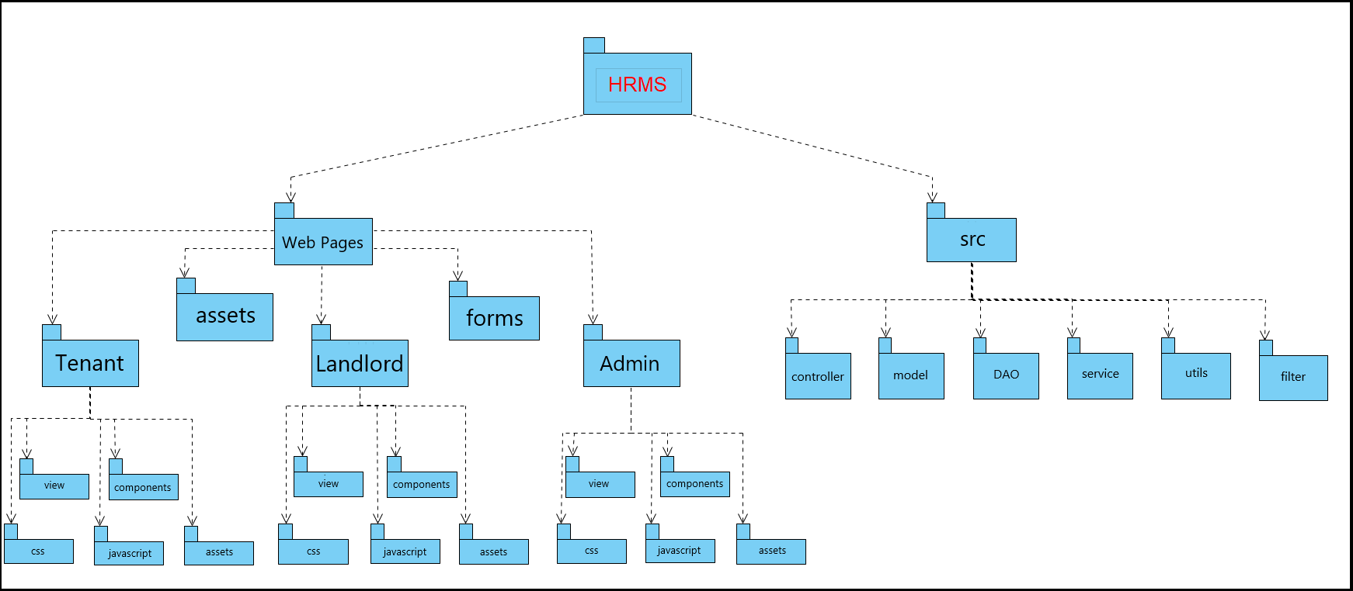

***Package descriptions***

| ***No*** | ***Package*** | ***Description*** |
| --- | --- | --- |
| *1* | *Web Pages* | *The Web Pages package contains Web Pages files* |
| *2* | *src* | *The src package contains all source code with .js, .css file* |
| *3* | *WEB-INF* | *The WEB-INF package contains web.xml , directory is private on web, can access by clients* |
| *4* | *Tenant* | *The Tenant package contains all file about source code of Tenant* |
| *5* | *Landlord* | *The Landlord package contains all file about source code of Landlord* |
| *6* | *Admin* | *The Admin package contains all file about source code of Admin* |
| *7* | *view\** | *The view package directory contains views pages* |
| *8* | *components\** | *The components package contains web component* |
| *9* | *css\** | *The css package contains css files* |
| *10* | *javascript\** | *The javascript package contains javascript files* |
| *11* | *assets\** | *The assets package contains the resources file such as image, icon* |
| *12* | *filter* | *The filter package contains all functionalities for data filtering* |
| *13* | *controller* | *The controller package contains all controllers of admin, tenant, landlord, post,...* |
| *14* | *service* | *The service package contains source code to manage all api requests and navigation* |
| *15* | *DAO* | *The DAO package contains Data Access files* |
| *16* | *model* | *The model contains source code to manage all entities* |

# II. Requirement Specifications

## 1. Login

### 1.1 UC01_Login

#### a. Functionalities

| UC id and Name: | UC-01_Login | | |
| --- | --- | --- | --- |
| Created By: | ThangHQ | Date Created: | 17/9/2023 |
| Primary Actor: | Tenant, Landlord, Admin | Secondary Actors |  |
| Trigger: | Click on “Login/Register” button at homepage for Tenant or Landlord role  Navigate to “<http://localhost:8080/SWP391-House-Rental-Management/admin-login?service=login>” to login as Admin role | | |
| Description: | Provide the email/username and password to authenticate with the system, logged in the system would bring more features. | | |
| Preconditions: | Email user used to login must be verified beforehand | | |
| Postconditions: | POST-1: Redirect to homepage of the website for the Tenant or Landlord, user’s profile page displayed at the top right corner of the page  POST-2: Redirect to admin dashboard for admin role, if login in admin-page  POST-3: Server session stores user identity | | |
| Normal Flow: | **1.0 Login for Tenant or Landlord**   | **Step** | **User action** | **System response** | | --- | --- | --- | | 1 | User click “Login/Register” button at the homepage | Display the login or Register page | | 2 | Users fill the required fields, including email and password. and then select the role | N/A | | 3 | User clicks on “Login” button | System check for inputted information, if the email, password and role are correct, redirect to the homepage. |   **1.1 Login for Admin**   | **Step** | **User action** | **System response** | | --- | --- | --- | | 1 | Admin enter URL “<http://localhost:8080/SWP391-House-Rental-Management/admin-login?service=login>” | Display login page for admin role | | 2 | Admin enter email and password | N/A | | 3 | Admin clicks on “Sign In” button | System check for credentials, if it is correct then redirect to admin dashboard, otherwise display login error | | | |
| Alternative Flows: | N/A | | |
| Exceptions: | **1.0.E1 Email, password or role is not correct**  The system inform user for incorrect information provided  **1.0.E2 Password does not meet criteria (length, uppercase, lowercase and special symbols)**  The system inform user for password does not meet requirements | | |
| Priority: | Must Have | | |
| Frequency of Use: | High | | |
| Business Rules: | BR-01, BR-02, BR-03, BR-04, BR-26 | | |
| Other Information: | N/A | | |
| Assumptions: | The email belonging to the account user used to log into the system must be verified before. | | |

#### b. Business Rules

| **id** | **Business Rule** | **Business Rule Description** |
| --- | --- | --- |
| BR-01 | Email validation | Accounts’ email must be valid (in the correct format) |
| BR-02 | Password validation | The system must validate the user’s password during login. The password should be encrypted and stored securely. |
| BR-03 | Logic condition | Only active users should be allowed to log in. Users with banned or deactivated accounts should not be able to log in. |
| BR-04 | Password Encoding | User’s password must be encoded with SHA512 hashing |
| BR-26 | Strong Password | Passwords used to login or register must contain at least 6 characters, 1 uppercase symbol, 1 lowercase symbol and 1 special symbol. |

## 2. Logout

### 2.1 UC02_Logout

#### a. Functionalities

| UC id and Name: | UC-02_Logout | | |
| --- | --- | --- | --- |
| Created By: | ThangHQ | Date created | 17/9/2023 |
| Primary Actor: | Tenant, Landlord, Admin | Secondary actor | N/A |
| Trigger: | On “My Profile” dropdown list, and then click on “Logout” | | |
| Description: | User logout of the system | | |
| Preconditions: | User have logged in the system | | |
| Postconditions: | POST-1: System returns the homepage after logged out successfully | | |
| Normal Flow: | **2.0 Logout**   | **Step** | **User action** | **System response** | | --- | --- | --- | | 1 | User click on the “logout” button | System redirects the user to homepage after logged out successfully | | | |
| Alternative Flows: | N/A | | |
| Exceptions: | N/A | | |
| Priority: | Must Have | | |
| Frequency of Use: | High | | |
| Business Rules: | BR-05 | | |
| Other Information: | N/A | | |
| Assumptions: | Users have logged in before they can log out. | | |

#### b. Business Rules

| **id** | **Business Rule** | **Business Rule Description** |
| --- | --- | --- |
| BR-05 | Logout condition | Users must be logged in to log out. |

## 3. Register

### 3.1 UC03_Register

#### a. Functionalities

| UC id and Name: | UC-03_Register | | |
| --- | --- | --- | --- |
| Created By: | ThangHQ | Date Created: | 16/9/2023 |
| Primary Actor: | Guest | Secondary Actors: |  |
| Trigger: | Click on “Login/Register” in Home page | | |
| Description: | User can create a new Tenant or Landlord account in the system | | |
| Preconditions: | User not logged in before. Email used to register must not be used by another activated account, or another account with the same role | | |
| Postconditions: | Redirect to homepage of the website for the client | | |
| Normal Flow: | **3.0 Register**   | **Step** | **User action** | **System response** | | --- | --- | --- | | 1 | Access to system homepage | System response the homepage to the user | | 2 | Click on “Login/Register” button | Display the “Login or Register page” | | 3 | User filled required fields, including First name, Last name, email, Password, Re-Password, Phone number, role. Then click on “Register” button | System sends an email to the user's email address, the email contains a verification link. | | 5 | User login to email and click on verification link | Display an email confirmation success page. | | | |
| Alternative Flows: | N/A | | |
| Exceptions: | **3.0.E1 Verification link expired**  At step 5 of normal flow, if the user does not click on the specified time interval, the registration link will be expired and no longer valid  **3.0.E2 Email already exists**  Register does not proceed, users are redirected to homepage, no confirmation email is sent. | | |
| Priority: | Must Have | | |
| Frequency of Use: | High | | |
| Business Rules: | BR-06, BR-07, BR-08 | | |
| Other Information: | N/A | | |
| Assumptions: | N/A | | |

#### b. Business Rules

| **id** | **Business Rule** | **Business Rule Description** |
| --- | --- | --- |
| BR-06 | Reject Duplicate Email | Cannot register with an email that has already been registered as the same role, or when there is another activated account using the same email. |
| BR-07 | Confirm Password | When registering or changing the password, the user must enter the new password twice. |
| BR-08 | Account Verification | If a user registered successfully, they must have an inactive account with code sent to email, when user follow the link sent to the mail, that account will be activated |

## 4. Password Retrievement

### 4.1 UC04_Forgot_Password

#### a. Functionalities

| UC id and Name: | UC-04_Forgot password | | |
| --- | --- | --- | --- |
| Created By: | ThangHQ | Date Created: | 17/9/2023 |
| Primary Actor: | Tenant, Landlord, Admin | Secondary Actors: |  |
| Trigger: | Click on “Forgot your password? Click here” in Login page or Home page | | |
| Description: | In cases of user cannot login to the system due to password forgotten, user can request for their password reset | | |
| Preconditions: | N/A | | |
| Postconditions: | Redirect to login page of the website for the client | | |
| Normal Flow: | **4.0 Forgot password**   | **Step** | **User action** | **System response** | | --- | --- | --- | | 1 | Access to system homepage | System response the homepage to the user | | 2 | Click on “Login/Register” button | Display the “Login or Register page” | | 3 | Click on “Forgot password?” | Display the forgot password page contains a form and let the user filling in | | 4 | User filled required fields, click on “Submit” button | System sends an email to the user's email address, the email contains a password reset link. | | 5 | User login to email and click on password reset link | System returns the form for the user inputs the new password | | | |
| Alternative Flows: | N/A | | |
| Exceptions: | **4.0.E1 Verification link expired**  At step 5 of normal flow, if the user does not click on the specified time interval, the password reset link will be expired and no longer valid  **4.0.E2 Email does not exist**  User is redirected to homepage, no reset password email is sent  **4.0.E3** **Email is not in correct format**  Error message display indicating incorrect email format | | |
| Priority: | Must Have | | |
| Frequency of Use: | High | | |
| Business Rules: | BR-07 | | |
| Other Information: | N/A | | |
| Assumptions: | The user need to have an verified account on the system beforehand | | |

#### b. Business Rules

| **id** | **Business Rule** | **Business Rule Description** |
| --- | --- | --- |
| BR-07 | Confirm Password | When registering or changing the password, the user must enter the new password twice. |

## 

## 5. Account management

### 5.1 UC05_Change password

#### a. Functionalities

| UC id and Name: | UC-05_Change password | | |
| --- | --- | --- | --- |
| Created By: | TungDT | Date Created: | 17/9/2023 |
| Primary Actor: | Tenant, Landlord | Secondary Actors: |  |
| Trigger: | Click on “Change your password” in Manage Profile page | | |
| Description: | User can change their own password | | |
| Preconditions: | The user need to have an account on the system and logged into the system | | |
| Postconditions: | User redirected to Manage Profile page | | |
| Normal Flow: | **5.0 Change password**   | **Step** | **User action** | **System response** | | --- | --- | --- | | 1 | Access to Manage Profile page | Display the account management page | | 2 | Click on “Change your password” button at sidebar | System redirect to a page that require user to enter the email | | 3 | User enter the registered email | System sends an email that verifies the request with a link to the change password page | | 4 | On the new page, user changes their password | System redirects user back to the home page | | | |
| Alternative Flows: | N/A | | |
| Exceptions: | **5.0.E1 Invalid email**  At step 3 of normal flow, if user enters an invalid email (unregistered or  unverified by admin), system will display an error message “Your email is invalid”  **5.0.E2 Verification link expired**  At step 3 of normal flow, if the user does not click on the verification link within 10 minutes after entering email, system will redirect user to the home page with a message “Verification link expired, please try again”  **5.0.E3** **New password does not match**  At step 4 of normal flow, if the “New password” and “Re-enter new password” does not match, system will display an error message “Your new password does not match” | | |
| Priority: | Must Have | | |
| Frequency of Use: | Low | | |
| Business Rules: | BR-07, BR-09, BR-16 | | |
| Other Information: | N/A | | |
| Assumptions: | N/A | | |

#### b. Business Rules

| **id** | **Business Rule** | **Business Rule Description** |
| --- | --- | --- |
| BR-07 | Confirm Password | When registering or changing the password, the user must enter the new password twice. |
| BR-09 | Request Expired | Ìf a user does not perform password changes within 10 minutes after the email is sent, then no changes will be applied. |
| BR-16 | Change different password | When changing password, the new password must not be the same as the current password. |

## 6. Profile management

### 6.1 UC06_Update profile

#### a. Functionalities

| UC id and Name: | UC-06_Update profile | | |
| --- | --- | --- | --- |
| Created By: | SyTT | Date Created: | 17/9/2023 |
| Primary Actor: | Tenant, Landlord | Secondary Actors: |  |
| Trigger: | Click on “Edit public information” in Manage Profile page | | |
| Description: | The user updates their own personal phone number, address, first name, last name. | | |
| Preconditions: | The user needs to be logged in | | |
| Postconditions: | The user is redirected back to the Manage Profile page and successfully updates their information. | | |
| Normal Flow: | **6.0 Update profile**   | **Step** | **User action** | **System response** | | --- | --- | --- | | 1 | From Home Page, navigate to My Profile and click on Manage Account | Display the account management page | | 2 | Click on “Edit public information” button at sidebar | Display form contains changeable field | | 3 | User filled in all required fields and click on “Submit” button | System returns the account management page, with information updated | | | |
| Alternative Flows: | N/A | | |
| Exceptions: | 1. **User inputs invalid phone number**   1a. Display pop-up message:     1. **User inputs invalid first name**   2a. Display pop-up message:     1. **User inputs invalid last name**   3a. Display pop-up message:     1. **User inputs invalid address**   4a. Display pop-up message: | | |
| Priority: | Must Have | | |
| Frequency of Use: | Low | | |
| Business Rules: | N/A | | |
| Other Information: | N/A | | |
| Assumptions: | N/A | | |

#### b. Business Rules

None

### 6.2 UC07_Upload User Avatar

#### a. Functionalities

| UC id and Name: | UC-07_Upload User Avatar | | |
| --- | --- | --- | --- |
| Created By: | Anh NT | Date created | 1/10/2023 |
| Primary Actor: | Tenant, Landlord | Secondary Actor | N/A |
| Trigger: | Click on “Chon Tep” in Manage Profile page | | |
| Description: | Users update their profile pictures. | | |
| Preconditions: | The user need to have an account on the system and logged into the system | | |
| Postconditions: | User redirected to Manage Profile page | | |
| Normal Flow: | **7.0 Upload User Avatar**   | **Step** | **User action** | **System response** | | --- | --- | --- | | 1 | The user accesses the personal information management page (Manage Profile). | Display the account management page | | 2 | The user clicks the "Chon Tept" button in the sidebar. | The system displays a form containing the avatar field. | | 3 | Users select a photo file from their computer and then click the "Upload/Update" button to update their profile picture. | Redirect to HomePage” | | | |
| Alternative Flows: | N/A | | |
| Exceptions: | N/A | | |
| Priority: | Normal | | |
| Frequency of Use: | Low | | |
| Business Rules: | BR-12 | | |
| Other Information: | N/A | | |
| Assumptions: | Users must log in to the system before accessing the account management page. | | |

#### b. Business Rules

| **id** | **Business Rule** | **Business Rule Description** |
| --- | --- | --- |
| BR-12 | Changing/Deleting confirmation | Every attempt of changing or deleting will result in a prompt for confirmation. |

#### 

## 7. Search post

### 7.1 UC08_Search post

#### a. Functionalities

| UC id and Name: | UC-08_Search post | | |
| --- | --- | --- | --- |
| Created By: | AnhNT | Date Created: | 17/9/2023 |
| Primary Actor: | Guest, Landlord, Tenant | Secondary Actors: | N/A |
| Trigger: | Click on “Search” in Home page | | |
| Description: | User can use search function to search for houses that meet some criteria | | |
| Preconditions: | N/A | | |
| Postconditions: | POST-1: System returns the result page contains houses that meet the provided criteria | | |
| Normal Flow: | **8.0 Search**   | **Step** | **User action** | **System response** | | --- | --- | --- | | 1 | Access to system homepage | System response the homepage to the user | | 2 | Users will select the desired attributes to search for the corresponding results | N/A | | 3 | Click on “Search Property” button | Returns the result page and displays houses that meet criteria | | | |
| Alternative Flows: | N/A | | |
| Exceptions: | N/A | | |
| Priority: | Must Have | | |
| Frequency of Use: | High | | |
| Business Rules: | BR-15 | | |
| Other Information: | N/A | | |
| Assumptions: | N/A | | |

#### b. Business Rules

| **id** | **Business Rule** | **Business Rule Description** |
| --- | --- | --- |
| BR-15 | Accurate search | The system must display the right posts based on the attribute searched. |

## 

## 8. View post list

### 8.1 UC09_View post list

#### a. Functionalities

| UC id and Name: | UC-09_View post list | | |
| --- | --- | --- | --- |
| Created By: | AnhNT | Date Created: | 30/9/2023 |
| Primary Actor: | Guest, Landlord, Tenant, Admin | Secondary Actors: | N/A |
| Trigger: | Click on “Houses” button on Header Home Page | | |
| Description: | User view the all House’s information by clicking on “ Houses “ button | | |
| Preconditions: | User have search for house using UC-08, or click on a link point to a house information page | | |
| Postconditions: | POST-1: System returns detailed page that display all Houses’s information | | |
| Normal Flow: | **9.0 View house detailed information**   | **Step** | **User action** | **System response** | | --- | --- | --- | | 1 | User click on the “Houses” button on Header Home Page | System response the Post information page | | | |
| Alternative Flows: | N/A | | |
| Exceptions: | N/A | | |
| Priority: | Must Have | | |
| Frequency of Use: | High | | |
| Business Rules: | N/A | | |
| Other Information: | N/A | | |
| Assumptions: | N/A | | |

#### b. Business Rules

None

### 

## 9. Home Page

### 9.1 UC10_View Home page

#### a. Functionalities

| UC id and Name: | UC-10_View home page | | |
| --- | --- | --- | --- |
| Created By: | AnhNT | Date Created: | 30/9/2023 |
| Primary Actor: | Guest, Landlord, Tenant, Admin | Secondary Actors: | N/A |
| Trigger: | Main System Page will displayed | | |
| Description: | Any user who visits the website will display the system's main screen | | |
| Preconditions: | User have search for house using UC-08, or click on a link point to a house information page | | |
| Postconditions: | System returns Home page that contain main things | | |
| Normal Flow: | N/A | | |
| Alternative Flows: | N/A | | |
| Exceptions: | N/A | | |
| Priority: | Must Have | | |
| Frequency of Use: | High | | |
| Business Rules: | N/A | | |
| Other Information: | N/A | | |
| Assumptions: | N/A | | |

#### b. Business Rules

None

## 10. View Post Detail

### 10.1 UC11_View post detail

#### a. Functionalities

| UC id and Name: | UC-11_View post detail | | |
| --- | --- | --- | --- |
| Created By: | AnhNT | Date Created: | 30/9/2023 |
| Primary Actor: | Guest, Landlord, Tenant, Admin | Secondary Actors: | N/A |
| Trigger: | Click on title of Post | | |
| Description: | Users view detailed information about the post by clicking on the post's title. | | |
| Preconditions: | The user searched for information about a house article using Use Case UC-08 or clicked a link pointing to a specific house details page. | | |
| Postconditions: | POST-1: System returns detailed page that display all Houses’s information | | |
| Normal Flow: | **11.0 View post detail**   | **Step** | **User action** | **System response** | | --- | --- | --- | | 1 | The user performs a search for information about the article or the house. | System response the Post information page | | 2 | The user clicks on the title of the article. | The system displays a detailed information page about the corresponding house. | | | |
| Alternative Flows: | N/A | | |
| Exceptions: | N/A | | |
| Priority: | Must Have | | |
| Frequency of Use: | High | | |
| Business Rules: | N/A | | |
| Other Information: | N/A | | |
| Assumptions: | N/A | | |

#### b. Business Rules

None

## 

## 11. Rating and reviews

### 11.1 UC12_Vote for post

#### a. Functionalities

| UC id and Name: | UC-12_Vote for post | | |
| --- | --- | --- | --- |
| Created By: | KhanhNB | Date Created: | 19/9/2023 |
| Primary Actor: | Tenant | Secondary Actors: |  |
| Trigger: | Select star on post comment and submit | | |
| Description: | Tenant can vote grade for that post | | |
| Preconditions: | Tenant need to have an account on the system and logged into the system | | |
| Postconditions: | Tenant redirected to Post | | |
| Normal Flow: | **12.0 Vote for post**   | **Step** | **User action** | **System response** | | --- | --- | --- | | 1 | Access to Home page | Display the Home page | | 2 | Access Post detail | Display the Post detail | | 3 | Select 1-5 star and submit | Display comment in Post comment | | | |
| Alternative Flows: | N/A | | |
| Exceptions: | N/A | | |
| Priority: | Normal | | |
| Frequency of Use: | Low | | |
| Business Rules: | N/A | | |
| Other Information: | N/A | | |
| Assumptions: | N/A | | |

#### b. Business Rules

None

### 11.2 UC13_Comment for post

#### a. Functionalities

| UC id and Name: | UC-13_Comment for post | | |
| --- | --- | --- | --- |
| Created By: | KhanhNB | Date Created: | 19/9/2023 |
| Primary Actor: | Tenant | Secondary Actors: |  |
| Trigger: | Click on “Comment” text field in Post | | |
| Description: | Tenant comment on post | | |
| Preconditions: | Tenant need to have an account on the system and logged into the system | | |
| Postconditions: | Tenant redirected to Report page | | |
| Normal Flow: | **13.0 Comment for post**   | **Step** | **User action** | **System response** | | --- | --- | --- | | 1 | Access to Home page | Display the Home page | | 2 | Access Post detail | Display the Post detail | | 3 | Write comment | A table will appear and the user will comment on that post | | | |
| Alternative Flows: |  | | |
| Exceptions: | N/A | | |
| Priority: | Must have | | |
| Frequency of Use: | Low | | |
| Business Rules: | BR-21, BR22 | | |
| Other Information: | N/A | | |
| Assumptions: | N/A | | |

#### b. Business Rules

| **id** | **Business Rule** | **Business Rule Description** |
| --- | --- | --- |
| BR-21 | Deny inappropriate comments | If a user’s comments use bad words, they will be warned and their comments will not be accepted. |
| BR-22 | Deny spamming | If a user makes too many comments on a post (spamming), their account will be banned. |

## 12. Wishlist

### 12.1 UC14_Add to wishlist

### a. Functionalities

| UC id and Name: | UC-14_Add to Wishlist | | |
| --- | --- | --- | --- |
| Created By: | ThangHQ | Date Created: | 19/9/2023 |
| Primary Actor: | Tenant | Secondary Actors: |  |
| Trigger: | Click on “Add to Wishlist” heart icon in a Post | | |
| Description: | The tenant can add a property to their wishlist to view it later. | | |
| Preconditions: | Tenant need to have an account on the system and logged into the system | | |
| Postconditions: | A property is added to tenant’s wishlist | | |
| Normal Flow: | **14.0 Add to Wishlist**   | **Step** | **User action** | **System response** | | --- | --- | --- | | 1 | Access to Home page | Display the Home page | | 2 | Click to view detail information a property | Display detailed information about a property | | 3 | Click on heart icon ♥️ near the post’s title | Message displays added to the wishlist successfully. | | | |
| Alternative Flows: | N/A | | |
| Exceptions: | N/A | | |
| Priority: | Normal | | |
| Frequency of Use: | Normal | | |
| Business Rules: | N/A | | |
| Other Information: | N/A | | |
| Assumptions: | Tenant already logged in the system | | |

#### b. Business Rules

N/A

### 12.2 UC15_View wish list

### a. Functionalities

| UC id and Name: | UC15_View wishlist | | |
| --- | --- | --- | --- |
| Created By: | ThangHQ | Date Created: | 31/10/2023 |
| Primary Actor: | Tenant | Secondary Actors: |  |
| Trigger: | On “My Profile” dropdown list, click on “My wishlist” | | |
| Description: | Tenant can view property they have been added to wishlist | | |
| Preconditions: | Tenant need to have an account on the system and logged into the system | | |
| Postconditions: | After clicking on My Wishlist, the tenant will be navigated to their Wishlist. | | |
| Normal Flow: | **15.0 View Wishlist**   | **Step** | **User action** | **System response** | | --- | --- | --- | | 1 | Access to Home page | Display the Home page | | 2 | Click on “My profile” | Display the dropdown menu of services for tenant | | 3 | Click on “My wishlist” | Display all items in the wishlist | | | |
| Alternative Flows: | N/A | | |
| Exceptions: | N/A | | |
| Priority: | Normal | | |
| Frequency of Use: | Normal | | |
| Business Rules: | N/A | | |
| Other Information: | N/A | | |
| Assumptions: | Tenant already logged in the system | | |

#### b. Business Rules

N/A

### 12.3 UC16_Remove from wishlist

### a. Functionalities

| UC id and Name: | UC16_Remove from wishlist | | |
| --- | --- | --- | --- |
| Created By: | ThangHQ | Date Created: | 31/10/2023 |
| Primary Actor: | Tenant | Secondary Actors: |  |
| Trigger: | Click on “Remove from wishlist” trash can icon in My Wishlist screen | | |
| Description: | Tenant can view property they have been added to wishlist, and choose to delete them from wishlist | | |
| Preconditions: | Tenant need to have an account on the system and logged into the system, also they need to have at least one item in the wishlist | | |
| Postconditions: | The property has just deleted is now disappear from wishlist | | |
| Normal Flow: | **16.0 View Wishlist**   | **Step** | **User action** | **System response** | | --- | --- | --- | | 1 | Access to Home page | Display the Home page | | 2 | Click on “My profile” | Display the dropdown menu of services for tenant | | 3 | Click on “View my wishlist” | Display all properties in the wishlist | | 4 | Click on Trash Can icon | Show the confirmation pop-up screen | | 5 | Click OK on the pop up screen | Remove the item from the wishlist. | | | |
| Alternative Flows: | 1.The tenant clicks on the solid heart icon in the Post Detail page.  System response: Shows pop-up screen: “Removed from wishlist” | | |
| Exceptions: | N/A | | |
| Priority: | Normal | | |
| Frequency of Use: | Normal | | |
| Business Rules: | N/A | | |
| Other Information: | N/A | | |
| Assumptions: | N/A | | |

#### b. Business Rules

N/A

## 13. Manage Order

### 13.1 UC17_ Create an order

#### a. Functionalities

#### 

| UC id and Name: | UC-17_Create order | | |
| --- | --- | --- | --- |
| Created By: | SyTT | Date Created: | 19/9/2023 |
| Primary Actor: | Tenant | Secondary Actors: |  |
| Trigger: | Click on “Order” button on post | | |
| Description: | Tenant can send an order for a room to the landlord for him/her to process | | |
| Preconditions: | Tenant need to have an account on the system and already logged into the system | | |
| Postconditions: | The tenant successfully places the order and the order is archived for the landlord to process. The order button switches to Pending… | | |
| Normal Flow: | **17.0 Create an Order**   | **Step** | **User action** | **System response** | | --- | --- | --- | | 1 | Access to Home page | Display the Home page | | 2 | Click on House page | Display all post | | 3 | Click on the post in which the tenant is interested. | Display the post detail page | | 2 | Click on Order button on post detail page | Display the Order Confirmation screen | | 3 | Click on Send Order button | Message: Order has been successfully submitted to the landlord. | | | |
| Alternative Flows: | N/A | | |
| Exceptions: | N/A | | |
| Priority: | Must have | | |
| Frequency of Use: | High | | |
| Business Rules: | N/A | | |
| Other Information: | N/A | | |
| Assumptions: | N/A | | |

#### b. Business Rules

None

### 13.2 UC18_Cancel order

#### a. Functionalities

| UC id and Name: | UC-18_Cancel order | | |
| --- | --- | --- | --- |
| Created By: | KhanhNB | Date Created: | 19/9/2023 |
| Primary Actor: | Tenant | Secondary Actors: |  |
| Trigger: | Click on “Cancel Order” button | | |
| Description: | Tenant can cancel order | | |
| Preconditions: | The tenant needs to have an account on the system and is logged into the system. And they need to have at least one order in the order list that is being processed. | | |
| Postconditions: | Tenant successfully erases the order from the order list. | | |
| Normal Flow: | **18.0 Cancel Order**   | **Step** | **User action** | **System response** | | --- | --- | --- | | 1 | Access to Home page | Display the Home page | | 2 | Select My Order | Display the list of the tenant’s orders | | 3 | Click on “x” button on the Order the tenant want to delete | Show confirmation pop up screen | |  | Click OK on the pop up screen | Delete the order and return to My Order | | | |
| Alternative Flows: | N/A | | |
| Exceptions: | **1.The user click on Cancel on the pop up screen**  The delete order action is canceled. | | |
| Priority: | Normal | | |
| Frequency of Use: | Medium | | |
| Business Rules: | BR-12 | | |
| Other Information: | N/A | | |
| Assumptions: | N/A | | |

#### b. Business Rules

| **id** | **Business Rule** | **Business Rule Description** |
| --- | --- | --- |
| BR-12 | Changing/Deleting confirmation | Every attempt of changing or deleting will result in a prompt for confirmation. |

None

### 13.3 UC19_View tenant’s orders

#### a. Functionalities

| UC id and Name: | UC-19_View tenant’s orders | | |
| --- | --- | --- | --- |
| Created By: | SyTT | Date Created: | 19/9/2023 |
| Primary Actor: | Tenant | Secondary Actors: |  |
| Trigger: | Click on “My Order” button on My Profile | | |
| Description: | Tenants can view all their orders. | | |
| Preconditions: | The tenant needs to have an account on the system and is logged into the system. | | |
| Postconditions: | Tenant redirected to Order list page | | |
| Normal Flow: | **19.0 View tenant’s order**   | **Step** | **User action** | **System response** | | --- | --- | --- | | 1 | Access to Home page | Display the Home page | | 2 | Click on My Order button on the My Profile dropdown list | Display the Order List | | | |
| Alternative Flows: | N/A | | |
| Exceptions: | N/A | | |
| Priority: | Must Have | | |
| Frequency of Use: | High | | |
| Business Rules: | BR-13 | | |
| Other Information: | N/A | | |
| Assumptions: | N/A | | |

#### b. Business Rules

| **id** | **Business Rule** | **Business Rule Description** |
| --- | --- | --- |
| BR-13 | Order Management | The system must maintain a record of all orders made by tenants, including the tenant who ordered, the landlord whose post is ordered, and status of order. |

## 14. Landlord Profile View

### 14.1 UC20_View landlord’s profile

#### a. Functionalities

#### 

| UC id and Name: | UC-20_View Landlord’s profile | | |
| --- | --- | --- | --- |
| Created By: | SyTT | Date Created: | 19/9/2023 |
| Primary Actor: | Tenant | Secondary Actors: |  |
| Trigger: | Click on “View landlord details” under their name in the landlord column of the Order list page. | | |
| Description: | Allows the tenant to see the landlord’s profile when that order has been approved by the landlord. | | |
| Preconditions: | The tenant needs to have an account on the system and is logged in.  The tenant needs to have at least one order approved by the landlord. | | |
| Postconditions: | The tenant is redirected to the landlord’s profile. | | |
| Normal Flow: | **20.0 View landlord’s profile**   | **Step** | **User action** | **System response** | | --- | --- | --- | | 1 | Access to Home page | Display the Home page | | 2 | Click on My orders from the “My profile” dropdown menu | Display all orders | | 3 | Click on “View landlord’s details” in an approved order | Display the landlord’s profile | | | |
| Alternative Flows: | N/A | | |
| Exceptions: | N/A | | |
| Priority: | Must Have | | |
| Frequency of Use: | High | | |
| Business Rules: | N/A | | |
| Other Information: | N/A | | |
| Assumptions: | N/A | | |

## 

## 15. System Report

### 15.1 UC21_Process Report

#### a. Functionalities

| UC id and Name: | UC-21_Process Report | | |
| --- | --- | --- | --- |
| Created By: | AnhNT | Date Created: | 19/9/2023 |
| Primary Actor: | Admin | Secondary Actors: |  |
| Trigger: | Click on “Process Report” in Admin Page | | |
| Description: | Admin can view all process reports | | |
| Preconditions: | Admin logs in to his/her correct account and goes to the admin's management page | | |
| Postconditions: | Admin redirected to Report page | | |
| Normal Flow: | **21.0. Process Report**   | **Step** | **User action** | **System response** | | --- | --- | --- | | 1 | Access to Report page | Display the process report page | | | |
| Alternative Flows: | N/A | | |
| Exceptions: | N/A | | |
| Priority: | Must Have | | |
| Frequency of Use: | High | | |
| Business Rules: | N/A | | |
| Other Information: | N/A | | |
| Assumptions: | N/A | | |

#### b. Business Rules

None

### 15.2 UC22_Send Report

#### a. Functionalities

| UC id and Name: | UC-22_Send Report | | |
| --- | --- | --- | --- |
| Created By: | SyTT | Date Created: | 19/9/2023 |
| Primary Actor: | Tenant, Landlord | Secondary Actors: |  |
| Trigger: | Click on the exclamation triangle icon in the header. | | |
| Description: | Tenant or Landlord can send report to the admin | | |
| Preconditions: | User need to have an account on the system and logged into the system | | |
| Postconditions: | Report is sent and archived for the admin to process. User is redirected back to Home Page | | |
| Normal Flow: | **22.0 Send Report**   | **Step** | **User action** | **System response** | | --- | --- | --- | | 1 | Access to Report Center | Display the Report page | | 2 | Input information regarding the user’s problem | Validating the information | | 3 | Click on Send report button | Show a success message. | | | |
| Alternative Flows: | 1. Tenants can report the post by clicking on the icon in the Post Detail page. 2. Tenants can report the landlord through viewing the landlord’s public profile, with the precondition that that landlord has approved the tenant’s request. 3. Landlords can report the tenant through viewing the tenant’s public profile, with the precondition that that landlord has approved the tenant’s request. | | |
| Exceptions: | 1. **User inputs invalid email**   Pop-up message:     1. **User inputs invalid post URL**   Pop-up message: | | |
| Priority: | High | | |
| Frequency of Use: | Must Have | | |
| Business Rules: | N/A | | |
| Other Information: | N/A | | |
| Assumptions: | N/A | | |

#### b. Business Rules

#### 

| **id** | **Business Rule** | **Business Rule Description** |
| --- | --- | --- |
| BR-01 | Email validation | Accounts’ email must be valid (in the correct format) |

### 15.3 UC23_View Report

#### a. Functionalities

| UC id and Name: | UC-23_View Report | | |
| --- | --- | --- | --- |
| Created By: | SyTT | Date Created: | 19/9/2023 |
| Primary Actor: | Tenant, Landlord | Secondary Actors: |  |
| Trigger: | Click on button “View previous reports” | | |
| Description: | Tenant or Landlord can view their report history | | |
| Preconditions: | User need to have an account on the system and logged into the system | | |
| Postconditions: | Display all reports made by the user | | |
| Normal Flow: | **23.0 View Report**   | **Step** | **User action** | **System response** | | --- | --- | --- | | 1 | Access to Report Center | Display the Report page | | 2 | Click on “View previous report” | Show list of reports made by the user. | | | |
| Alternative Flows: | N/A | | |
| Exceptions: | N/A | | |
| Priority: | Medium | | |
| Frequency of Use: | Low | | |
| Business Rules: | N/A | | |
| Other Information: | N/A | | |
| Assumptions: | N/A | | |

#### b. Business Rules

None

### 15.4 UC24_Cancel Report

#### a. Functionalities

| UC id and Name: | UC-24_Cancel Report | | |
| --- | --- | --- | --- |
| Created By: | SyTT | Date Created: | 19/9/2023 |
| Primary Actor: | Tenant, Landlord | Secondary Actors: |  |
| Trigger: | Click on the “x” icon in Report history page | | |
| Description: | Tenant or Landlord can cancel their made report | | |
| Preconditions: | User need to have an account on the system and logged into the system  The user needs to have made at least one report before. | | |
| Postconditions: | The report is erased | | |
| Normal Flow: | **24.0 Cancel Report**   | **Step** | **User action** | **System response** | | --- | --- | --- | | 1 | Access to Report Center | Display the Report page | | 2 | Click on “View previous report” | Show list of reports made by the user. | | 3 | Click the “x” button | Show confirmation pop-up message | | 4 | Click OK in the pop-up | Remove the report from the list | | | |
| Alternative Flows: | N/A | | |
| Exceptions: | 1. **User clicks Cancel in the pop-up**   The delete action is canceled. | | |
| Priority: | Low | | |
| Frequency of Use: | Low | | |
| Business Rules: | BR-12 | | |
| Other Information: | N/A | | |
| Assumptions: | N/A | | |

#### b. Business Rules

#### 

| **id** | **Business Rule** | **Business Rule Description** |
| --- | --- | --- |
| BR-12 | Changing/Deleting confirmation | Every attempt of changing or deleting will result in a prompt for confirmation. |

## 

## 16. Post Management

### 16.1 UC25_Publish new post

#### a. Functionalities

#### 

| UC id and Name: | UC-25_Publish new post | | |
| --- | --- | --- | --- |
| Created By: | AnhNT | Date Created: | 19/9/2023 |
| Primary Actor: | Landlord | Secondary Actors: |  |
| Trigger: | Click on “Add New Post” in Manage Services page | | |
| Description: | Landlords can add a new post about their new property | | |
| Preconditions: | The landlord needs to be logged in.  The landlord needs to have specifications of their new property for input. | | |
| Postconditions: | Landlord is redirected to Payment screen | | |
| Normal Flow: | **25.0 Publish new post**   | **Step** | **User action** | **System response** | | --- | --- | --- | | 1 | Access to Manage Services | Display the Manage Services page | | 2 | Click on Add new post | Display the list of input for the landlord | | 3 | After filling all fields, click submit now | Redirect to the payment screen | | | |
| Alternative Flows: | N/A | | |
| Exceptions: | N/A | | |
| Priority: | High | | |
| Frequency of Use: | High | | |
| Business Rules: | N/A | | |
| Other Information: | N/A | | |
| Assumptions: | N/A | | |

#### b. Business Rules

None

### 16.2 UC26_Update a post

#### a. Functionalities

#### 

| UC id and Name: | UC-26_Update a post | | |
| --- | --- | --- | --- |
| Created By: | AnhNT | Date Created: | 19/9/2023 |
| Primary Actor: | Landlord | Secondary Actors: |  |
| Trigger: | Click on “Post” Manage Profile | | |
| Description: | Landlord updates informations about their houses | | |
| Preconditions: | The user need to have an account on the system and logged into the system | | |
| Postconditions: | Landlord redirected to Manage page | | |
| Normal Flow: | **26.0 Update Post**   | **Step** | **User action** | **System response** | | --- | --- | --- | | 1 | Access to Manage Profile | Display the Manage page | | 2 | Click on New Post | Landlord enters information about the houses | | | |
| Alternative Flows: | N/A | | |
| Exceptions: | N/A | | |
| Priority: | Normal | | |
| Frequency of Use: | Low | | |
| Business Rules: | BR-12 | | |
| Other Information: | N/A | | |
| Assumptions: | N/A | | |

#### b. Business Rules

| **id** | **Business Rule** | **Business Rule Description** |
| --- | --- | --- |
| BR-12 | Changing/Deleting confirmation | Every attempt of changing or deleting will result in a prompt for confirmation. |

### 16.3 UC27_Remove apost

#### a. Functionalities

#### 

| UC id and Name: | UC-27_Remove apost | | |
| --- | --- | --- | --- |
| Created By: | TienPV | Date Created: | 19/9/2023 |
| Primary Actor: | Landlord | Secondary Actors: |  |
| Trigger: | Click on “Post” Manage Profile | | |
| Description: | Landlord updates informations about their houses | | |
| Preconditions: | The user need to have an account on the system and logged into the system | | |
| Postconditions: | Landlord redirected to Manage page | | |
| Normal Flow: | **27.0 Remove a post**   | **Step** | **User action** | **System response** | | --- | --- | --- | | 1 | Access to Manage Profile | Display the Manage page | | 2 | Click on New Post | Landlord enters information about the houses | | | |
| Alternative Flows: | N/A | | |
| Exceptions: | N/A | | |
| Priority: | Normal | | |
| Frequency of Use: | Low | | |
| Business Rules: | BR-12 | | |
| Other Information: | N/A | | |
| Assumptions: | N/A | | |

#### b. Business Rules

| **id** | **Business Rule** | **Business Rule Description** |
| --- | --- | --- |
| BR-12 | Changing/Deleting confirmation | Every attempt of changing or deleting will result in a prompt for confirmation. |

### 16.4 UC28_Hide a post

#### a. Functionalities

| UC id and Name: | UC-28_Hide a post | | |
| --- | --- | --- | --- |
| Created By: | AnhNT | Date Created: | 19/9/2023 |
| Primary Actor: | Admin | Secondary Actors: |  |
| Trigger: | Click on “Edit Post” Manage Profile | | |
| Description: | Admin can disable any post | | |
| Preconditions: | The admin needs to be logged in  The posts list needs to include at least one post | | |
| Postconditions: | Post is set to “deleted” state  The post no longer appeared for neither the Tenant nor the Landlord. | | |
| Normal Flow: | **28.0 Hide a post**   | **Step** | **User action** | **System response** | | --- | --- | --- | | 1 | Access to Manage Post interface | Display the all posts | | 2 | Click the red delete button | Post is set to “deleted” state | | | |
| Alternative Flows: | N/A | | |
| Exceptions: | N/A | | |
| Priority: | Normal | | |
| Frequency of Use: | Low | | |
| Business Rules: | BR-12 | | |
| Other Information: | N/A | | |
| Assumptions: | N/A | | |

#### b. Business Rules

#### 

| **id** | **Business Rule** | **Business Rule Description** |
| --- | --- | --- |
| BR-12 | Changing/Deleting confirmation | Every attempt of changing or deleting will result in a prompt for confirmation. |

### 16.5 UC29_View all personal post

#### a. Functionalities

| UC id and Name: | UC-29_View all personal post | | |
| --- | --- | --- | --- |
| Created By: | TienPV | Date Created: | 19/9/2023 |
| Primary Actor: | Landlord | Secondary Actors: |  |
| Trigger: | Click on “Published posts” on Manage Services | | |
| Description: | Landlord can view posts they have been posted | | |
| Preconditions: | **PRE-1**: Landlord need to be logged in | | |
| Postconditions: | **POST-1**: Display all posts landlord have been posted | | |
| Normal Flow: | **29. View all personal post**   | **Step** | **User action** | **System response** | | --- | --- | --- | | 1 | From homepage, click on “Manage Services” at header | Display Manage Service page for landlord | | 2 | Click on “Published posts” | Display all posts of that landlord | | | |
| Alternative Flows: | N/A | | |
| Exceptions: | N/A | | |
| Priority: | Normal | | |
| Frequency of Use: | Low | | |
| Business Rules: | N/A | | |
| Other Information: | N/A | | |
| Assumptions: | Landlord already logged in | | |

#### b. Business Rules

#### 

N/A

### 16.6 UC30_Pay for post

#### a. Functionalities

| UC ID and Name: | UC-30_Pay for post | | |
| --- | --- | --- | --- |
| Created By: | TienPV | Date Created: | 19/9/2023 |
| Primary Actor: | Landlord | Secondary Actors: |  |
| Trigger: | Click on “Select” at a package of your choice in Payment page | | |
| Description: | Landlord can choose between Basic, Standard and Premium packages to pay for their post | | |
| Preconditions: | **PRE-1**: Landlord already filled in “Add a new post” form and submit the form | | |
| Postconditions: | **POST-1**: Post is submitted, landlord balance is subtract according to the package they chose, status of post based on the package | | |
| Normal Flow: | **30.0 Pay for post**   | **Step** | **User action** | **System response** | | --- | --- | --- | | 1 | From landlord Manage Services page, click on Add a new post | Display form to fill in the information of a post | | 2 | Landlord filled in all information related to the post, including Post Title, Rental price, House area, Number of bedrooms, Address of a house, photos, Detailed description, type, location, Save as Draft or payment. At this step, they choose Payment and then click on Submit Now button | Display Payment page to let landlord choose packages to pay for a post | | 3 | Landlord choose a package as they wish and click “Select” | Display a prompt “Do you really want to pay for this package?” | | 4 | Landlord choose OK | Display the property | | | |
| Alternative Flows: | N/A | | |
| Exceptions: | N/A | | |
| Priority: | High | | |
| Frequency of Use: | Low | | |
| Business Rules: | BR-12 | | |
| Other Information: | N/A | | |
| Assumptions: | N/A | | |

#### b. Business Rules

#### 

| **id** | **Business Rule** | **Business Rule Description** |
| --- | --- | --- |
| BR-12 | Changing/Deleting confirmation | Every attempt of changing or deleting will result in a prompt for confirmation. |

## 17. User Account Manipulation

### 17.1 UC31_Add account

#### a. Functionalities

| UC id and Name: | UC-31_Add Account | | |
| --- | --- | --- | --- |
| Created By: | TungDT | Date Created: | 8/10/2023 |
| Primary Actor: | Admin | Secondary Actors: |  |
| Trigger: | Click on “Add New Admin Account” or “Add New Tenant/Landlord Account in Manage Account page | | |
| Description: | Admin can add an account with Admin or Tenant/Landlord role | | |
| Preconditions: | The user need to have an account on the system and logged into the system | | |
| Postconditions: | Admin redirected to Manage Profile page | | |
| Normal Flow: | **31.0. Add admin account**   | **Step** | **User action** | **System response** | | --- | --- | --- | | 1 | Access to Manage Account | Display Manage Account page | | 2 | Click on Add New Admin Account | Display Add Admin Account page | | 3 | Enter information for the new account | If successful, system will add a new account with admin role to the database |   **31.1. Add tenant/landlord account**   | **Step** | **User action** | **System response** | | --- | --- | --- | | 1 | Access to Manage Account | Display Manage Account page | | 2 | Click on Add New Tenant/Landlord Account | Display Add Tenant/Landlord page | | 3 | Enter information for the new account | If successful, system will add a new account with admin role to the database | | | |
| Alternative Flows: | N/A | | |
| Exceptions: | N/A | | |
| Priority: | Normal | | |
| Frequency of Use: | Low | | |
| Business Rules: | N/A | | |
| Other Information: | N/A | | |
| Assumptions: | N/A | | |

#### b. Business Rules

None

### 17.2 UC32_Update account

#### a. Functionalities

| UC id and Name: | UC-32_Update Account | | |
| --- | --- | --- | --- |
| Created By: | TungDT | Date Created: | 8/10/2023 |
| Primary Actor: | Admin | Secondary Actors: |  |
| Trigger: | Click on “Edit” in an account in Manage Profile page | | |
| Description: | Admin can edit account | | |
| Preconditions: | The user need to have an account on the system and logged into the system | | |
| Postconditions: | Admin redirected to Manage Profile page | | |
| Normal Flow: | **32.0 Update Account**   | **Step** | **User action** | **System response** | | --- | --- | --- | | 1 | Access to Manage Profile | Display the Manage page | | 2 | Click on Edit on an account | Display the Edit Account page | | 3 | Change the information on the account | If successful, system will performchanges to the account in the database |   N/A | | |
| Alternative Flows: | N/A | | |
| Exceptions: | BR-12 | | |
| Priority: | Normal | | |
| Frequency of Use: | Low | | |
| Business Rules: | N/A | | |
| Other Information: | N/A | | |
| Assumptions: | N/A | | |

#### b. Business Rules

| **id** | **Business Rule** | **Business Rule Description** |
| --- | --- | --- |
| BR-12 | Changing/Deleting confirmation | Every attempt of changing or deleting will result in a prompt for confirmation. |

### 17.3 UC33_Disable account

#### a. Functionalities

| UC id and Name: | UC-33_Disable Account | | |
| --- | --- | --- | --- |
| Created By: | TungDT | Date Created: | 8/10/2023 |
| Primary Actor: | Admin | Secondary Actors: |  |
| Trigger: | Click on “Delete” in an account in Manage Account page | | |
| Description: | Admin can disable an account | | |
| Preconditions: | The user need to have an account with admin role on the system and logged that account into the system | | |
| Postconditions: | Admin redirected to Manage Account page | | |
| Normal Flow: | **33.0 Disable account**   | **Step** | **User action** | **System response** | | --- | --- | --- | | 1 | Access to Users List | Display the Manage page | | 2 | Click on Delete button next to an account | System disable the account | | | |
| Alternative Flows: | N/A | | |
| Exceptions: | BR-12 | | |
| Priority: | Normal | | |
| Frequency of Use: | Low | | |
| Business Rules: | N/A | | |
| Other Information: | N/A | | |
| Assumptions: | N/A | | |

#### b. Business Rules

#### 

| **id** | **Business Rule** | **Business Rule Description** |
| --- | --- | --- |
| BR-12 | Action enabler | Every attempt of changing or deleting will result in a prompt for confirmation. |

### 

### 17.4 UC34_Ban account

#### a. Functionalities

| UC id and Name: | UC-34_Ban Account | | |
| --- | --- | --- | --- |
| Created By: | ThangHQ | Date Created: | 8/10/2023 |
| Primary Actor: | Admin | Secondary Actors: |  |
| Trigger: | Click on “Ban” in an account in Account Utilities page | | |
| Description: | Admin can Ban an account for a pre-defined duration (100, 200, 365 days or permanent) | | |
| Preconditions: | PRE-1. The user need to have an account with admin role on the system and logged that account into the system | | |
| Postconditions: | POST1. Page reloaded, response Account Utilities page  POST2. Status of banned account is now Banned | | |
| Normal Flow: | **34.0 Ban account**   | **Step** | **User action** | **System response** | | --- | --- | --- | | 1 | Access to Account Utilities page | Display the Account Utilities page | | 2 | Click on Ban button next to an account | Display User Information page | | 3 | 1. User review information of banned account  2. Choose a Ban duration  3. Click on Save Changes | Account status is set to “Banned” with updated duration  Account utilities page reloaded | | | |
| Alternative Flows: | **34.1 Cancel ban action**   | **Step** | **User action** | **System response** | | --- | --- | --- | | 1 | Access to Account Utilities page | Display the Account Utilities page | | 2 | Click on Ban button next to an account | Display User Information page | | 3 | 1. User review information of banned account  2. Choose a Ban duration  3. Click on Cancel button | Redirect to Manage Account page | | | |
| Exceptions: | N/A | | |
| Priority: | Normal | | |
| Frequency of Use: | Low | | |
| Business Rules: | N/A | | |
| Other Information: | N/A | | |
| Assumptions: | N/A | | |

#### b. Business Rules

N/A

### 

### 17.5 UC35_Unban account

#### a. Functionalities

| UC id and Name: | UC-35_Unban Account | | |
| --- | --- | --- | --- |
| Created By: | ThangHQ | Date Created: | 8/10/2023 |
| Primary Actor: | Admin | Secondary Actors: |  |
| Trigger: | Click on “Un-ban” in an account in Account Utilities page | | |
| Description: | Admin can unban an account | | |
| Preconditions: | PRE-1. The user need to have an account with admin role on the system and logged in with that account | | |
| Postconditions: | POST-1. Page reloaded the same page  POST-2. Status of unbanned account is now Unverified | | |
| Normal Flow: | **35.0 Disable account**   | **Step** | **User action** | **System response** | | --- | --- | --- | | 1 | Access to admin Account Utilities page | Display the Account Utilities page | | 2 | Click on Un-ban button next to an banned account | Page reload, response the same Account Utilities page, with status of unbanned account is now Unverified | | | |
| Alternative Flows: | N/A | | |
| Exceptions: | N/A | | |
| Priority: | Normal | | |
| Frequency of Use: | Low | | |
| Business Rules: | N/A | | |
| Other Information: | N/A | | |
| Assumptions: | N/A | | |

#### b. Business Rules

#### 

N/A

### 17.6 UC36_View all account

#### a. Functionalities

| UC id and Name: | UC-36_View all account | | |
| --- | --- | --- | --- |
| Created By: | TungDT | Date Created: | 8/10/2023 |
| Primary Actor: | Admin | Secondary Actors: |  |
| Trigger: | Click on “Manage Account” in Admin page | | |
| Description: | Admin can view all accounts in system | | |
| Preconditions: | The user need to have an account with admin role on the system and logged that account into the system | | |
| Postconditions: | Admin redirected to Manage Account page | | |
| Normal Flow: | **36.0 View all account**   | **Step** | **User action** | **System response** | | --- | --- | --- | | 1 | Click on Manage Account in the sidebar | Display all account in system | | | |
| Alternative Flows: | N/A | | |
| Exceptions: | BR-12 | | |
| Priority: | Normal | | |
| Frequency of Use: | Low | | |
| Business Rules: | N/A | | |
| Other Information: | N/A | | |
| Assumptions: | N/A | | |

#### b. Business Rules

#### 

| **id** | **Business Rule** | **Business Rule Description** |
| --- | --- | --- |
| BR-12 | Action enabler | Every attempt of changing or deleting will result in a prompt for confirmation. |

### 

## 18. Order management

### 18.1 UC37_View landlord’s orders

#### a. Functionalities

| UC id and Name: | UC37_View landlord’s orders | | |
| --- | --- | --- | --- |
| Created By: | TienPV | Date Created: | 19/9/2023 |
| Primary Actor: | Landlord | Secondary Actors: |  |
| Trigger: | Click on “Manage Services” button | | |
| Description: | Landlords can check and manage all orders related to the building they manage. Consists of 2 parts pending requests and request processed | | |
| Preconditions: | PRE-1: The user logs in with landlord roles.  PRE-2: landlords need at least one post to exist.  PRE-3: Landlords need to have at least one outstanding order.  PRE-4: The system displays all orders that have not been processed. | | |
| Postconditions: | POST-1: The system returns the result "reject" or "approve" exactly as the user did. | | |
| Normal Flow: | **37.0 View landlord’s orders**   | **Step** | **User action** | **System response** | | --- | --- | --- | | 1 | The user logs in with landlord roles. | The system returns to the home page. | | 2 | Landlord click on “Manage Services” Button in header. | The system returns orders that have not been processed. | | 3 | Landlord click on “Requests processed” Button in the navbar. | The system returns orders that have been processed. | | | |
| Alternative Flows: | N/A | | |
| Exceptions: | N/A | | |
| Priority: | Must Have | | |
| Frequency of Use: | High | | |
| Business Rules: | BR-11, BR-19, BR-20 | | |
| Other Information: | N/A | | |
| Assumptions: | N/A | | |

#### b. Business Rules

| **id** | **Business Rule** | **Business Rule Description** |
| --- | --- | --- |
| BR-11 | Change Post status | When a landlord approves a booking request from a tenant, the status of a Post will be modified from Available to Occupied to fit the changes. |
| BR-19 | Order process privilege | To process the order list, user must have the Landlord role |
| BR-20 | Landlord order process | Landlords can only process the orders from their posts. |

### 18.2 UC38_Process Order

#### a. Functionalities

| UC id and Name: | UC-38_Process order | | |
| --- | --- | --- | --- |
| Created By: | TienPV | Date Created: | 19/9/2023 |
| Primary Actor: | Landlord | Secondary Actors: |  |
| Trigger: | Click on “Reject” or “Approve” with a certain column of order information. | | |
| Description: | Landlords manage their orders by approving or canceling tenant requests. | | |
| Preconditions: | The landlord needs to have an account on the system and is logged in.  The landlord needs to have at least one order in processing state. | | |
| Postconditions: | Landlord successfully changed the status of the order to “approved” or “rejected”.  Redirected back to the Order manager page | | |
| Normal Flow: | **38.0 Process Order**   | **Step** | **User action** | **System response** | | --- | --- | --- | | 1 | The user logs in with landlord roles. | The system returns to the home page. | | 2 | Landlord click on “Manage Services” Button in header. | The system returns orders that have not been processed. | | 3 | At the end of each line of data, choose between 2 buttons "reject" and "approve" | The system immediately confirms the request and reloads the page | | | |
| Alternative Flows: | N/A | | |
| Exceptions: | N/A | | |
| Priority: | Must have | | |
| Frequency of Use: | High | | |
| Business Rules: | BR-23, BR-24, BR-25 | | |
| Other Information: | Orders that have completed the approve and reject steps are considered by the system to have completed processing and cannot be modified. | | |
| Assumptions: | N/A | | |

#### b. Business Rules

| **id** | **Business Rule** | **Business Rule Description** |
| --- | --- | --- |
| BR-23 | Approve/reject orders privilege | To approve/ reject orders, the user must log in with landlord roles. |
| BR-24 | Availability of approve/reject orders | Landlords can only approve or reject orders that have not been processed yet. |
| BR-25 | Uniqueness of approve/reject orders | The operation of approve or reject orders can only be done once. |

## 19. Point Management

### 19.1 UC39_Add point to landlord

#### a. Functionalities

#### 

| UC id and Name: | UC39_Add point to landlord | | |
| --- | --- | --- | --- |
| Created By: | ThangHQ | Date created | 1/10/2023 |
| Primary Actor: | Admin | Secondary Actor | N/A |
| Trigger: | Click on “Add Point” button in Account Utilities admin page | | |
| Description: | Admin can add point to a Landlord account | | |
| Preconditions: | An admin need to be logged in the system and do the point transaction | | |
| Postconditions: | POST-1: System returns Account Utilities page, with account’s point of landlord increased | | |
| Normal Flow: | **39.0 Add point to landlord**   | **Step** | **User action** | **System response** | | --- | --- | --- | | 1 | Admin click on Member management button | Member management dashboard | | 2 | Select a landlord account then click on “Add Point” button. | The add point page | | 3 | Admin check the account field (readonly), and fill in the amount of point to add | N/A | | 4 | Click “Submit” button | System responses the account utilities page, the account point of selected landlord increased | | | |
| Alternative Flows: | N/A | | |
| Exceptions: | **39.0.E1 Amount of point is smaller or equal to 0**  Error message displayed indicating error in adding point | | |
| Priority: | Must Have | | |
| Frequency of Use: | High | | |
| Business Rules: | N/A | | |
| Other Information: | N/A | | |
| Assumptions: | Admin account logged in the system | | |

#### b. Business Rules

None

## 

### 19.2 UC40_View transaction history

#### a. Functionalities

#### 

| UC id and Name: | UC40_View transaction history | | |
| --- | --- | --- | --- |
| Created By: | ThangHQ | Date created | 1/10/2023 |
| Primary Actor: | Landlord | Secondary Actor | N/A |
| Trigger: | Click on the “View Transaction History” button in the Account Management page. | | |
| Description: | Landlords can view their transaction history for each post they’ve paid for and deposit | | |
| Preconditions: | Landlord must log in the system, with the role landlord. | | |
| Postconditions: | POST-1: System returns Point Management page, that displays transaction history | | |
| Normal Flow: | **40.0 Point transaction history**   | **Step** | **User action** | **System response** | | --- | --- | --- | | 1 | Landlord click on Manage Service button at My Profile dropdown list | Account Management page | | 2 | Landlord clicks on Transaction History under Manage my waller points section | The Point Management page contains transaction history. | | | |
| Alternative Flows: | N/A | | |
| Exceptions: | N/A | | |
| Priority: | High | | |
| Frequency of Use: | Normal | | |
| Business Rules: | N/A | | |
| Other Information: | N/A | | |
| Assumptions: | The account currently log in the system is Landlord. | | |

#### b. Business Rules

None

## 20. Tenant Profile View

### 20.1 UC41_View tenant profile

#### a. Functionalities

#### 

| UC id and Name: | UC-41_View Tenant Information | | |
| --- | --- | --- | --- |
| Created By: | TienPV | Date created | 1/10/2023 |
| Primary Actor: | Landlord | Secondary Actor | N/A |
| Trigger: | Click on tenant’s name title | | |
| Description: | Landlords can view all details about their tenants | | |
| Preconditions: | Landlord redirected to Tenant manager | | |
| Postconditions: | POST-1: System returns detailed page that display all information about Tenant’s Information | | |
| Normal Flow: | **41.0 Tenant detailed information**   | **Step** | **User action** | **System response** | | --- | --- | --- | | 1 | Landlord click on “Tenant’s Name” title | System response the detailed tenant information page | | | |
| Alternative Flows: | N/A | | |
| Exceptions: | N/A | | |
| Priority: | Must Have | | |
| Frequency of Use: | High | | |
| Business Rules: | BR-14 | | |
| Other Information: | N/A | | |
| Assumptions: | N/A | | |

#### b. Business Rules

| BR-14 | Facts | The system must maintain a record of all tenants, including their contact information, rental history, and payment status. |
| --- | --- | --- |

## 

## 21. Promotion Management

### 21.1 UC42_Update promotion

#### a. Functionalities

| UC id and Name: | UC-42_Update Promotion | | |
| --- | --- | --- | --- |
| Created By: | KhanhNB | Date Created: | 30/9/2023 |
| Primary Actor: | Landlord | Secondary Actors: | N/A |
| Trigger: | Click “Edit“ on the Promotion landlord want to change | | |
| Description: | Landlords can edit a new promotional offer, such as reduced rent or incentives, to attract potential tenants to their rental listing. | | |
| Preconditions: | Promotions must be already existed in database | | |
| Postconditions: |  | | |
| Normal Flow: | **42.0 Update Promotion**   | **Step** | **User action** | **System response** | | --- | --- | --- | | 1 | Access to Home page | Display the Home page | | 2 | Click on Promotion | Display the Promotion Manage | | 3 | Click on Edit on the Promotion landlord want to change | Display Edit Promotion Form with Promotion’s information | | 4 | Insert promotion’s information and click Submit | Collect data,insert into database and redirect to Promotion Manage | | | |
| Alternative Flows: | N/A | | |
| Exceptions: | N/A | | |
| Priority: | Normal | | |
| Frequency of Use: | Low | | |
| Business Rules: | BR-12 | | |
| Other Information: | N/A | | |
| Assumptions: | N/A | | |

#### b. Business Rules

| **id** | **Business Rule** | **Business Rule Description** |
| --- | --- | --- |
| BR-12 | Changing/Deleting confirmation | Every attempt of changing or deleting will result in a prompt for confirmation. |

### 21.2 UC43_Create promotion

#### a. Functionalities

| UC id and Name: | UC-43_Create Promotion | | |
| --- | --- | --- | --- |
| Created By: | KhanhNB | Date Created: | 30/9/2023 |
| Primary Actor: | Landlord | Secondary Actors: | N/A |
| Trigger: | Click “ Add Promotion Form“ on Promotion Manage | | |
| Description: | Landlord can create new promotion on their post | | |
| Preconditions: | Landlord need to have an account on the system and logged into the system | | |
| Postconditions: | Landlord redirected to Add Promotion Form | | |
| Normal Flow: | **43.0 Create Promotion**   | **Step** | **User action** | **System response** | | --- | --- | --- | | 1 | Access to Home page | Display the Home page | | 2 | Click on Promotion | Display the Promotion Manage | | 3 | Click on Add Promotion Form | Display Add Promotion Form | | 4 | Select property ,insert promotion’s information and click Submit | Collect data and insert into database | | | |
| Alternative Flows: | N/A | | |
| Exceptions: | N/A | | |
| Priority: | Normal | | |
| Frequency of Use: | Low | | |
| Business Rules: | N/A | | |
| Other Information: | N/A | | |
| Assumptions: | N/A | | |

#### b. Business Rules

None

### 21.3 UC44_Remove Promotion

#### a. Functionalities

| UC id and Name: | UC-44_Remove Promotion | | |
| --- | --- | --- | --- |
| Created By: | KhanhNB | Date Created: | 30/9/2023 |
| Primary Actor: | Landlord | Secondary Actors: | N/A |
| Trigger: | Click “Delete“ on the Promotion landlord want to remove | | |
| Description: | Landlords can select an active promotion, confirm removal, and remove it from the rental listing to end the promotional offer. | | |
| Preconditions: | Promotions must be already existed in database | | |
| Postconditions: |  | | |
| Normal Flow: | **44.0 Remove Promotion**   | **Step** | **User action** | **System response** | | --- | --- | --- | | 1 | Access to Home page | Display the Home page | | 2 | Click on Promotion | Display the Promotion Manage | | 3 | Click on Delete on the Promotion landlord want to remove | Remove that promotion and redirect to Promotion Manage | | | |
| Alternative Flows: | N/A | | |
| Exceptions: | N/A | | |
| Priority: | Normal | | |
| Frequency of Use: | Low | | |
| Business Rules: | BR-12 | | |
| Other Information: | N/A | | |
| Assumptions: | N/A | | |

#### b. Business Rules

| **id** | **Business Rule** | **Business Rule Description** |
| --- | --- | --- |
| BR-12 | Changing/Deleting confirmation | Every attempt of changing or deleting will result in a prompt for confirmation. |

### 21.4 UC45_View Promotion

#### a. Functionalities

| UC id and Name: | UC-45_View Promotion | | |
| --- | --- | --- | --- |
| Created By: | KhanhNB | Date Created: | 30/9/2023 |
| Primary Actor: | Landlord | Secondary Actors: | N/A |
| Trigger: | Click on “Houses” button on Header Home Page | | |
| Description: | Display promotion information of the house | | |
| Preconditions: | N/A | | |
| Postconditions: | N/A | | |
| Normal Flow: | **45.0 View Promotion**   | **Step** | **User action** | **System response** | | --- | --- | --- | | 1 | Access to Home page | Display the Home page | | 2 | Click on Houses | Display list of house with promotion information of the house | | | |
| Alternative Flows: | N/A | | |
| Exceptions: | N/A | | |
| Priority: | Normal | | |
| Frequency of Use: | Low | | |
| Business Rules: | BR-12 | | |
| Other Information: | N/A | | |
| Assumptions: | N/A | | |

#### b. Business Rules

#### 

| **id** | **Business Rule** | **Business Rule Description** |
| --- | --- | --- |
| BR-12 | Changing/Deleting confirmation | Every attempt of changing or deleting will result in a prompt for confirmation. |

### 

### 21.5 UC46_Update promotion duration

#### a. Functionalities

| UC id and Name: | UC-46_Update duration of promotion | | |
| --- | --- | --- | --- |
| Created By: | KhanhNB | Date Created: | 30/9/2023 |
| Primary Actor: | Landlord | Secondary Actors: | N/A |
| Trigger: | Click “Set Duration“ on the Promotion landlord want to change | | |
| Description: | Landlords can extends or modifies the duration of an existing promotional offer on their rental listing to attract and inform potential tenants | | |
| Preconditions: | Promotions must be already existed in database | | |
| Postconditions: |  | | |
| Normal Flow: | **46.0 Update promotion**   | **Step** | **User action** | **System response** | | --- | --- | --- | | 1 | Access to Home page | Display the Home page | | 2 | Click on Promotion | Display the Promotion Manage | | 3 | Click on Set Duration on the Promotion landlord want to change | Display Edit Promotion Form with Promotion’s information | | 4 | Insert promotion’s information and click Submit | Collect data,insert into database and redirect to Promotion Manage | | | |
| Alternative Flows: | N/A | | |
| Exceptions: | N/A | | |
| Priority: | Normal | | |
| Frequency of Use: | Low | | |
| Business Rules: | BR-12 | | |
| Other Information: | N/A | | |
| Assumptions: | N/A | | |

#### b. Business Rules

| **id** | **Business Rule** | **Business Rule Description** |
| --- | --- | --- |
| BR-12 | Changing/Deleting confirmation | Every attempt of changing or deleting will result in a prompt for confirmation. |

# 

# III. Design Specifications

## 1. Login

### 1.1 Login

#### a. User Login

This screen allows users to be authenticated to the system screens/functionalities.

##### UI Design

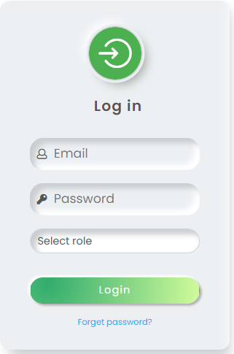

| **Field Name** | **Field Type** | **Description** |
| --- | --- | --- |
| ***Field Group Name*** | | |
| Email | Text | Tenant enters email to log in. |
| Password | Text | The user enter the password to login. Passwords must be at least 6 characters, 1 uppercase symbol, 1 lowercase symbol, and 1 special symbol. |
| Role | Combobox | User select role they want to log in (Tenant or Landlord) |

##### Database Access

| **Table** | **CRUD** | **Description** |
| --- | --- | --- |
| User | R | System will check to see if it matches the data in the database. |
| User_banned | R | Check to see whether this user is banned |

***SQL Commands***

1. Get user by email and roleid

SELECT * FROM Users WHERE email = ? AND role_id = ?;

2. Check banned status

SELECT * FROM User_banned WHERE id = ?;

## 2. Logout

### 2.1 Logout

#### a. User Logout

This screen allows users to be log out from the system

##### UI Design

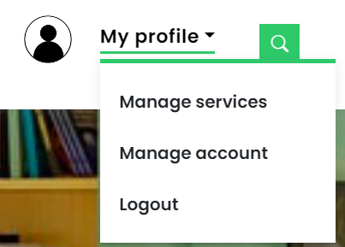

| **Field Name** | **Field Type** | **Description** |
| --- | --- | --- |
| Logout | Button | Click on the button will log out the user. |

##### Database Access

| **Table** | **CRUD** | **Description** |
| --- | --- | --- |
| N/A | N/A | N/A |

***SQL Commands***

N/A

## 3. Register

### 3.1 Register

#### a. Guest Register

##### UI Design

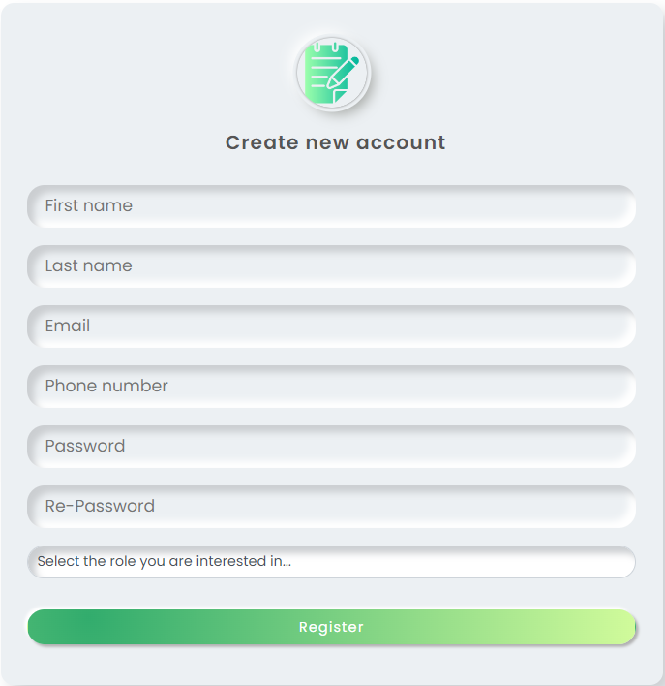

| **Field Name** | **Field Type** | **Description** |
| --- | --- | --- |
| ***Field Group Name*** | | |
| First name | Text | The Guest will enter the required boxes in the table that appears on the website to be able to register and guest can choose what they gonna be ( tenant, landlord ) |
| Last name | Text | User’s last name |
| Email | Text | User’s email address |
| Phone number | Text | User’s phone number |
| Password | Text | User’s password |
| Re-password | Text | Re-enter the password |
| Role | Combo box | The role user want to register |
| Register | Button | Button to submit the register form |

##### Database Access

| **Table** | **CRUD** | **Description** |
| --- | --- | --- |
| User | C, R | The system will add the newly entered customer information into the database |
| Landlord | C | The system will add the newly entered Landlord information into the database |
| Tenant | C | The system will add the newly entered Tenant information into the database |

***SQL Commands***

1/ Check whether in the DB has an account with this email address

SELECT * FROM Users WHERE email = ?;

2/ Insert into Users table

INSERT INTO Users(email, hashed_password, salt, role_id, status VALUES (?,?,?,?,?);

3/ Insert into Tenant table (if user selected to register as Tenant)

INSERT INTO Tenant (id, first_name, last_name, address, phone, civil_id) VALUES (?, ?, ?, ?, ?, ?);

4/ Insert into Landlord table (if user selected to register as Landlord)

INSERT INTO [Landlord] ([id],[first_name],[last_name],[address],[phone],[civil_id],[account_points]) VALUES (?,?,?,?,?,?,?);

5/ Generate token for email confirmation

INSERT INTO [Token]\ ([user_id], [email], [token], [expired_date], [type]) VALUES (?, ?, ?, ?, ?);

## 4. Password Retrievement

#### 4.1. Forgot Password

##### UI Design

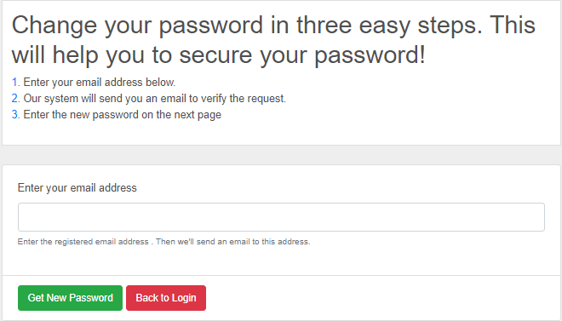

| **Field Name** | **Field Type** | **Description** |
| --- | --- | --- |
| ***Field Group Name*** | | |
| Email | Text | You will have to enter the email where you want to retrieve your password |
| Get New Password | Button | Submit email to get reset password link (if email exists) |
| Back to Login | Button | Back to Login page |

##### Database Access

| **Table** | **CRUD** | **Description** |
| --- | --- | --- |
| User | R | The system will send a link so you can click and reset a new password |
| Token | C, R | System needs to access the Token table to read (verify token valid) and insert token. |

***SQL Commands***

1\ Check email exists

SELECT id FROM Users WHERE email = ?;

2\ Check verified account

SELECT * FROM Users WHERE email = ? AND status != ‘UNV’;

3\ Get user by email

SELECT * FROM Users WHERE email = ?;

4\ Generate forgot password token

INSERT INTO [Token] ([user_id], [email], [token], [expired_date], [type]) VALUES (?, ?, ?, ?, ?);

5\ Get token

SELECT * FROM Token WHERE token = ?;

6\ Update password

UPDATE [dbo].[Users] SET [email] = ?, [hashed_password] = ?, [salt] = ?, [role_id] = ?, [status] = ? WHERE id = ?;

## 5. Account management

#### 5.1. Update personal password

##### UI Design

Verify password:

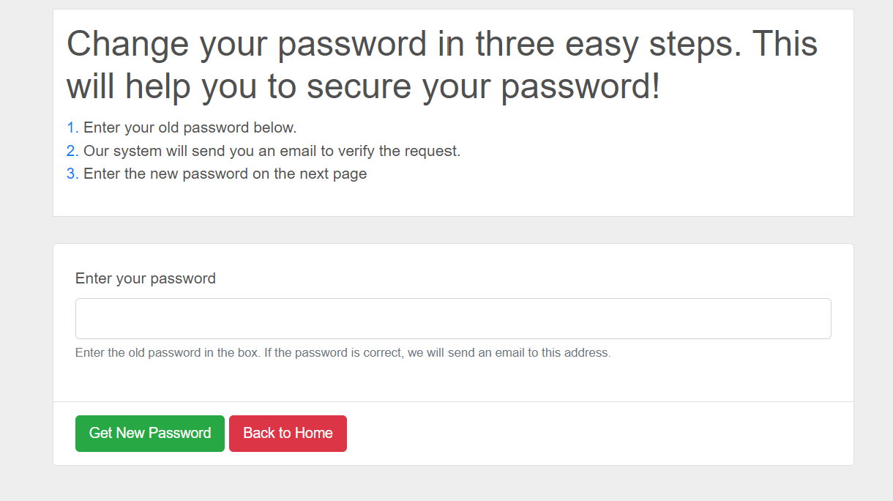

Change password:

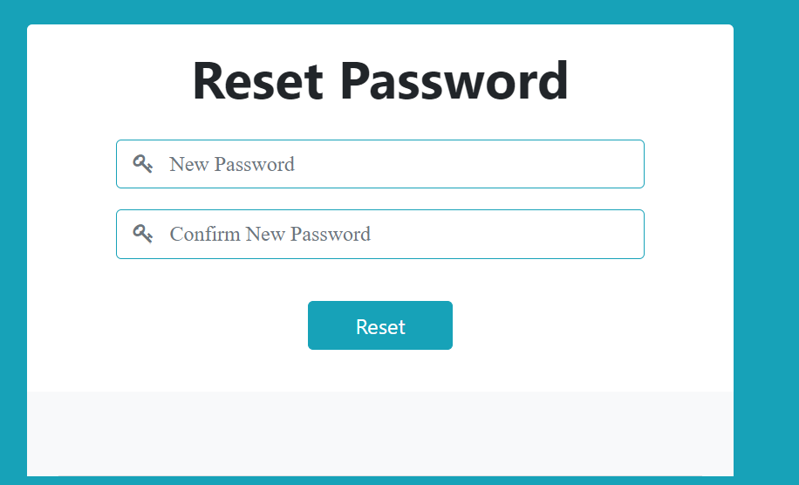

| **Field Name** | **Field Type** | **Description** |
| --- | --- | --- |
| ***Verify password*** | | |
| Password | Password | Enter user old password |
| ***Change Password*** | | |
| Password | Password | User enter new password |
| Re_password | Password | User confirm new password |
| Reset | Button | Send data to database and change user password |

##### Database Access

| **Table** | **CRUD** | **Description** |
| --- | --- | --- |
| Tenant, LandLord, Admin | U | The system will update the data according to what the user has entered and wants to change |

***SQL Commands***

UPDATE Tenant SET first_name= value1, last_name= value2, address= value3, phone= value4 WHERE condition;

UPDATE LandLord SET first_name= value1, last_name= value2, address= value3, phone= value4 WHERE condition;

UPDATE Admin SET first_name= value1, last_name= value2, address= value3, phone= value4 WHERE condition;

## 

## 6. Profile management

#### 6.1. Update profile

##### UI Design

Update profile

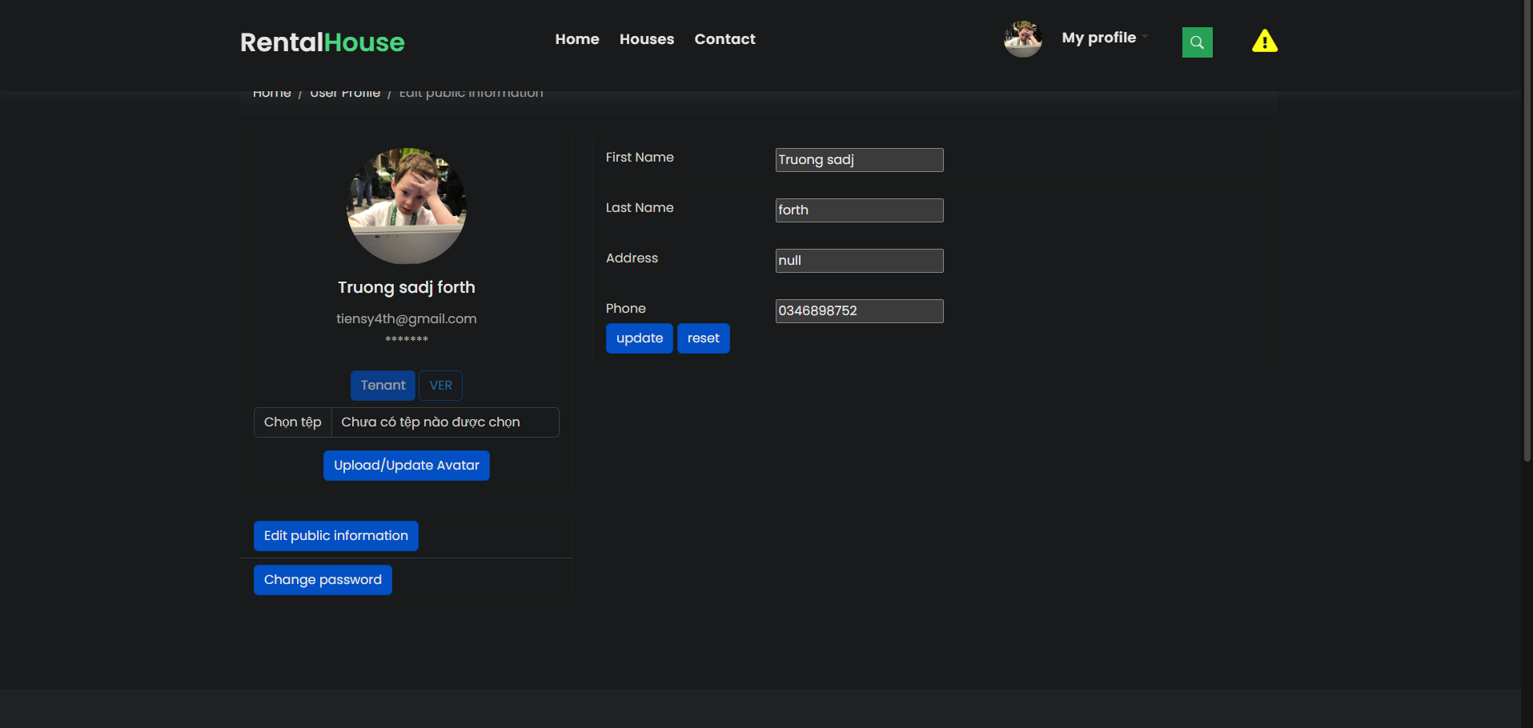

| **Field Name** | **Field Type** | **Description** |
| --- | --- | --- |
| ***Change information*** | | |
| First Name | Text | User enter new first name |
| Last Name | Text | User enter new last name |
| Address | Text | User enter new address |
| Phone | Number | User enter new phone number |
| Update | Button | User confirm the update |
| Reset | Button | User reset the personal information to initial state |

##### Database Access

| **Table** | **CRUD** | **Description** |
| --- | --- | --- |
| Tenant, LandLord | U | The system will update the data according to what the user has entered and wants to change |

***SQL Commands***

UPDATE Tenant SET first_name= value1, last_name= value2, address= value3, phone= value4 WHERE condition;

UPDATE LandLord SET first_name= value1, last_name= value2, address= value3, phone= value4 WHERE condition;

UPDATE Admin SET first_name= value1, last_name= value2, address= value3, phone= value4 WHERE condition;

## 

#### 6.2. Upload user avatar

##### UI Design

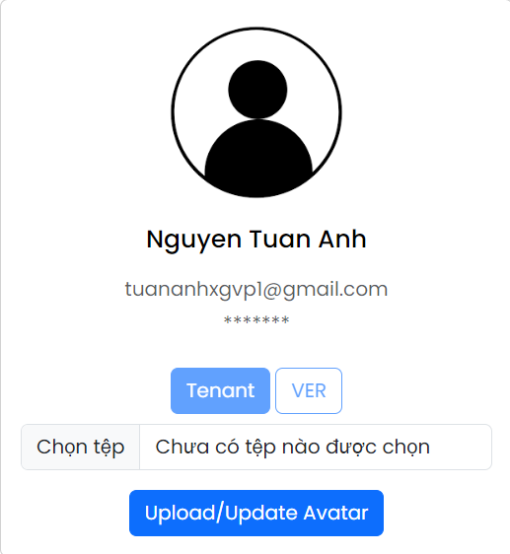

| **Field Name** | **Field Type** | **Description** |
| --- | --- | --- |
| Name | Text | Display name of User |
| Email | Text | Display email of User |
| UserRole | Text | Display UserRole of User |
| Status | Text | Display Status of User |
| Chọn Tệp | Button | Allow users to choose image from their computer to apply for Avatar |
| Upload/Update Avatar | Button | System will update image to User’s Profile |

##### Database Access

| **Table** | **CRUD** | **Description** |
| --- | --- | --- |
| UserAvatar | U | The system will update the data url image according to what the users has upload and want to change |

***SQL Commands***

## 7. Search Post

#### 7.1. Search post

##### UI Design

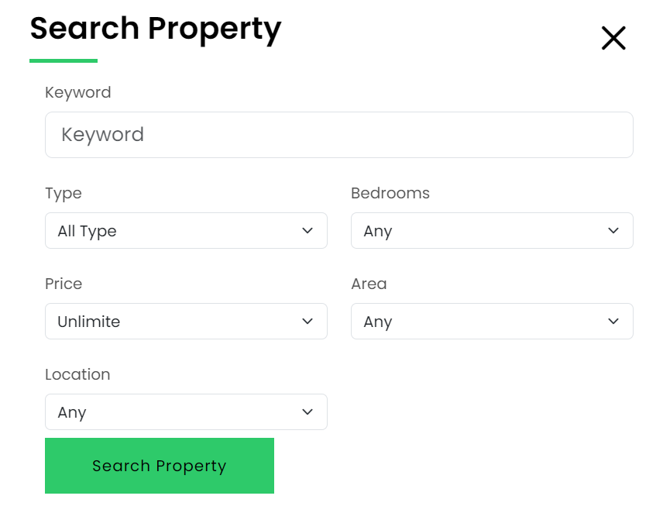

| **Field Name** | **Field Type** | **Description** |
| --- | --- | --- |
| Keyword | Text | Allow user to input text to search by keyword |
| Type | Select | Allow user to choose Type to search by type |
| Bedrooms | Select | Allow user to choose Bedrooms to search by number of bedrooms |
| Price | Select | Allow user to choose price to search by price |
| Area | Select | Allow user to choose area to search by area |
| Location | Select | Allow user to choose location to search by location |
| Search | Text | Users can search for houses according to their criteria and preferences |

##### 

##### Database Access

| **Table** | **CRUD** | **Description** |
| --- | --- | --- |
| Post | R | The system will display all detailed data about the house on the website after user search |
| .. |  |  |

***SQL Commands***

SELECT a.* FROM Post a JOIN Property_Location b ON a.location_id = b.id

WHERE a.status != 'draft' AND a.status != 'deleted' AND a.name LIKE ? AND a.type = ? AND a.NumOfBedrooms = ? AND a.price <= ? AND a.area <= ? AND b.id = ? ORDER BY a.id OFFSET ? ROWS FETCH FIRST 9 ROWS ONLY

## 8. View Post List

#### 8.1. View post list

##### UI Design

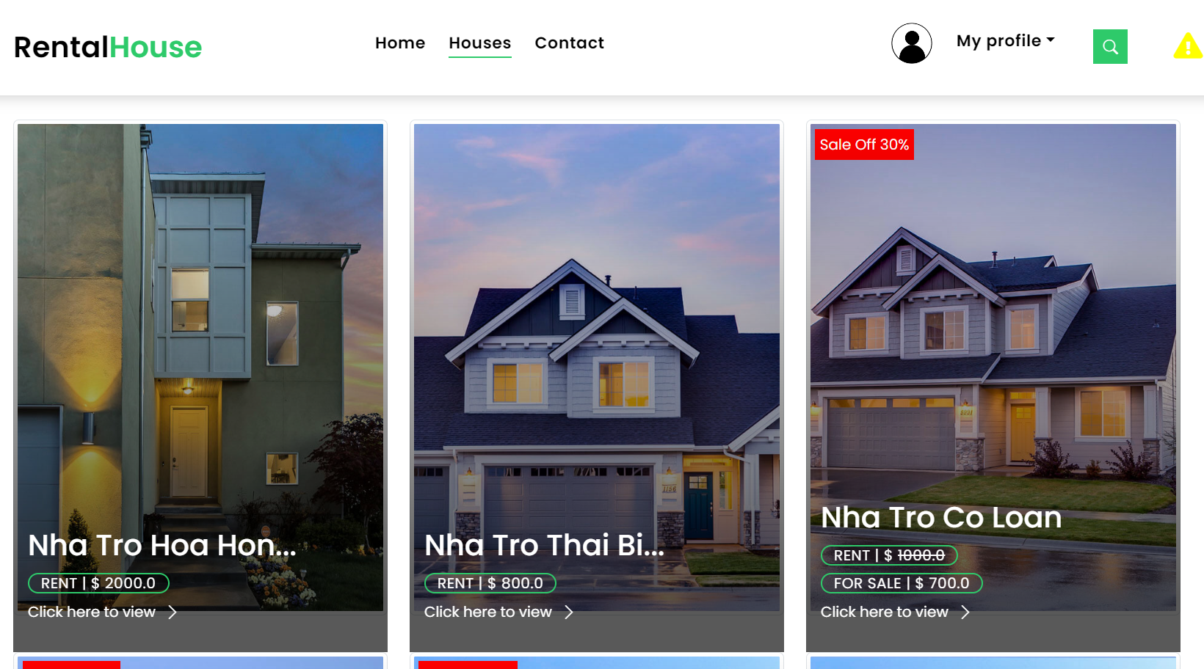

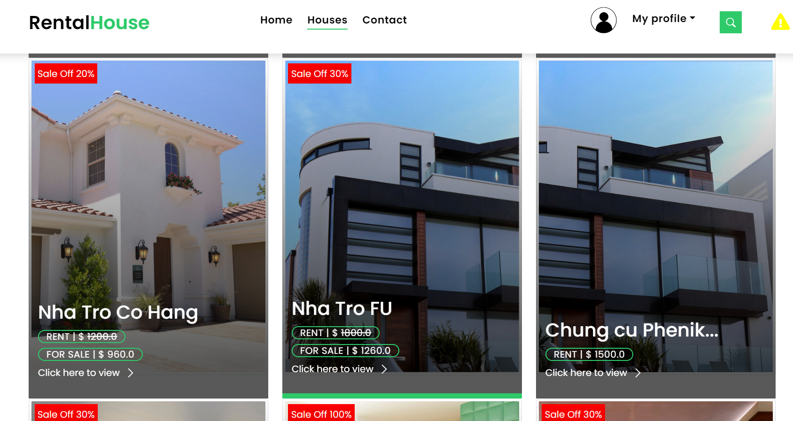

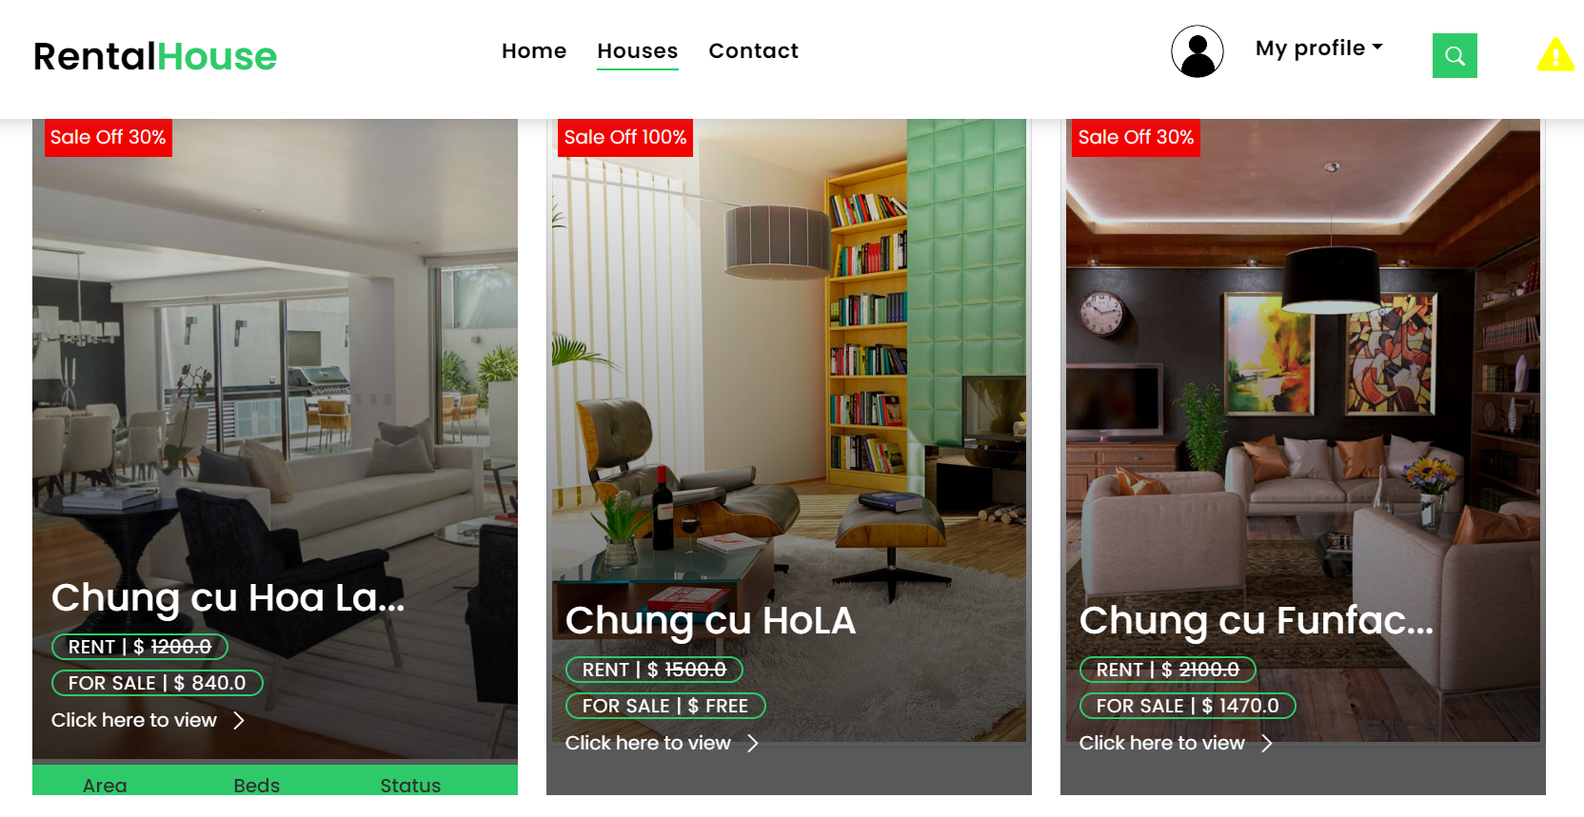

| **Field Name** | **Field Type** | **Description** |
| --- | --- | --- |
| ***Field Group Name*** | | |
| View | Text | Users can see posts about houses for rent |

##### 

##### Database Access

| **Table** | **CRUD** | **Description** |
| --- | --- | --- |
| Post | R | The system will display all data about the house in database on the website |
| .. |  |  |

***SQL Commands***

SELECT * FROM Post

## 

## 9. View Home Page

#### 9.1. View home page

##### UI Design

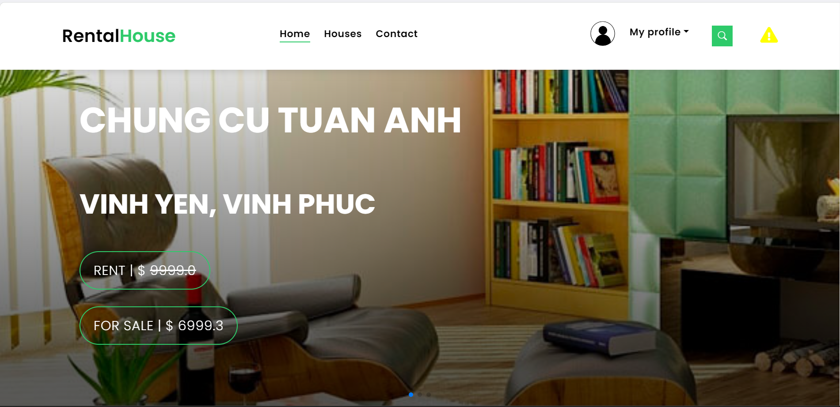

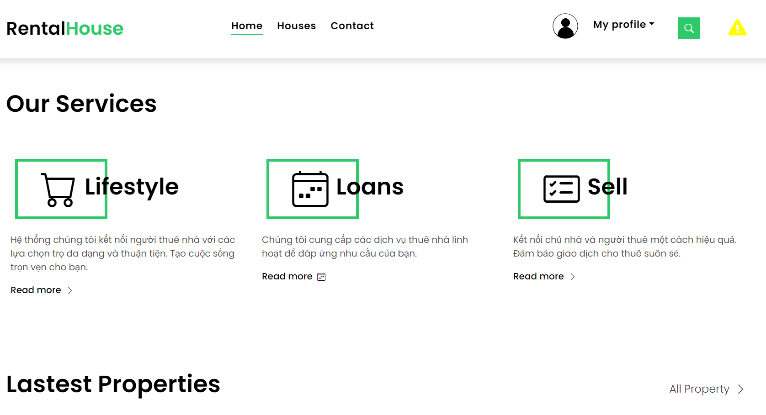

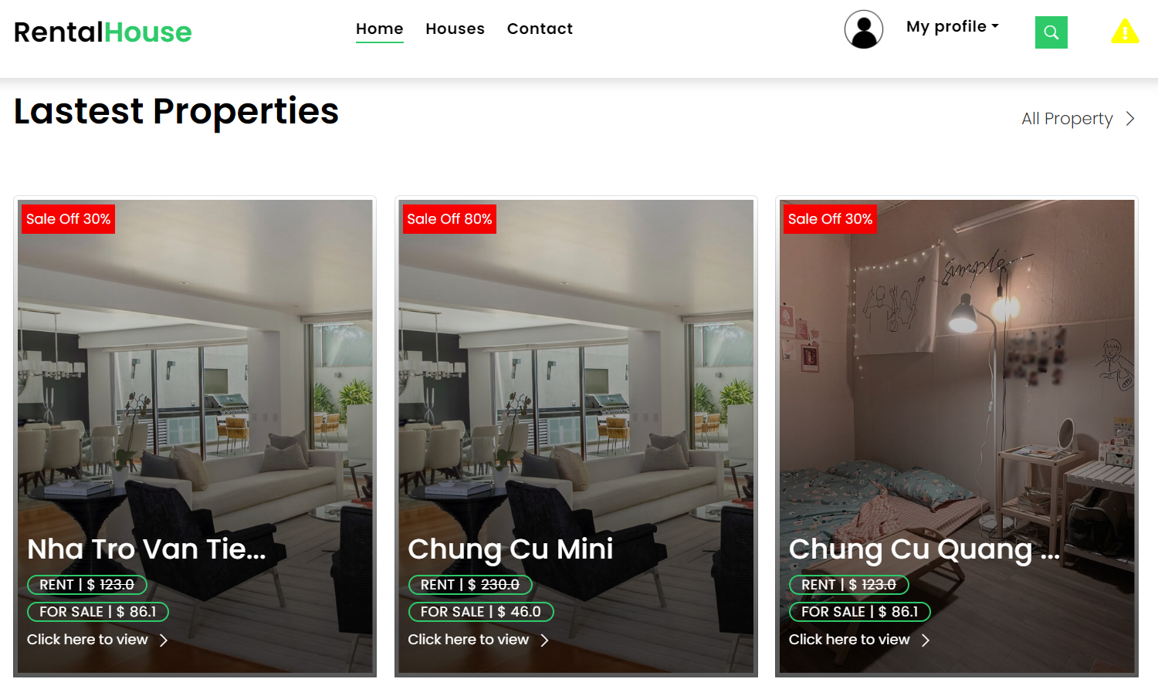

| **Field Name** | **Field Type** | **Description** |
| --- | --- | --- |
| ***Field Group Name*** | | |
| View | Text | Users can see posts about houses for rent |

##### Database Access

| **Table** | **CRUD** | **Description** |
| --- | --- | --- |
| Post | R | The system will display all data about the house on the website |

***SQL Commands***

SELECT TOP 3 * FROM Post where status != 'draft' and status != 'deleted' ORDER BY price DESC

SELECT TOP 4 * FROM Post where status != 'draft' and status != 'deleted' ORDER BY post_start_date DESC;

## 10. View Post Detail

##### UI Design

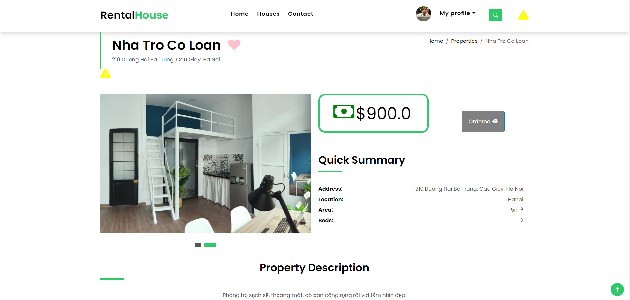

| **Field Name** | **Field Type** | **Description** |
| --- | --- | --- |
| ***Field Group Name*** | | |
| View | Text | Users can see details post which users choose |

##### 

##### Database Access

| **Table** | **CRUD** | **Description** |
| --- | --- | --- |
| Post | R | The system will display detailed data about the house on the website |

***SQL Commands***

select *from post where id = ?

## 11. Rating and reviews

### 11.1 Vote for post

##### UI Design

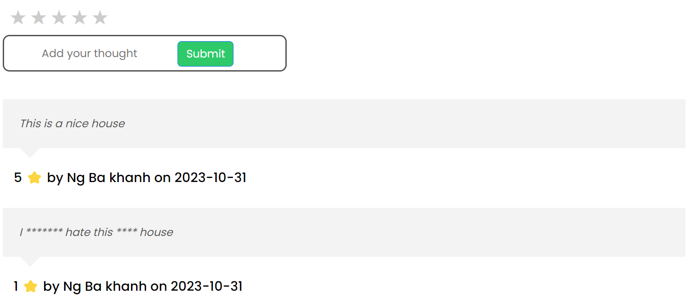

| **Field Name** | **Field Type** | **Description** |
| --- | --- | --- |
| Star | Radio box | Allow tenant to select star |
| Submit | Button | Submit star for post comment |

##### Database Access

| **Table** | **CRUD** | **Description** |
| --- | --- | --- |
| Review | C,R | The system will add star to Post |

##### SQL Commands

* Add star to database:

INSERT INTO [dbo].[Review]([user_id],[property_id],[review_date] ,[rating],[review]

VALUES (? ,? ,? ,? ,?)

* Display star:

SELECt a.rating,a.review,b.first_name,b.last_name,b.phone,a.review_date

FROM Review a JOIN Tenant b ON a.user_id=b.id WHERE property_id = ?

### 

### 11.2 Comment for room

##### UI Design

**

| **Field Name** | **Field Type** | **Description** |
| --- | --- | --- |
| Comment | Text | Allow tenant to add comment |
| Submit | Button | Submit star for post comment |

##### Database Access

| **Table** | **CRUD** | **Description** |
| --- | --- | --- |
| Review | C,R | The system will add star to Post |

##### SQL Commands

* Add comment to database:

INSERT INTO [dbo].[Review]([user_id],[property_id],[review_date] ,[rating],[review]

VALUES (? ,? ,? ,? ,?)

* Display comment:

SELECt a.rating,a.review,b.first_name,b.last_name,b.phone,a.review_date

FROM Review a JOIN Tenant b ON a.user_id=b.id WHERE property_id = ?

## 12. Wishlist

### 12.1 Add to Wishlist

##### UI Design

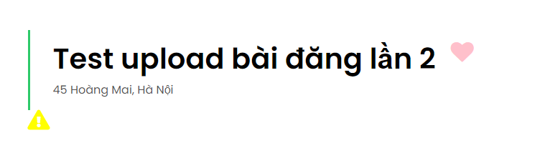

| **Field name** | **Field type** | **Description** |
| --- | --- | --- |
| *Heart* icon | Button | Click into the heart icon to add property to the tenant's wishlist. |

##### Database Access

| **Table** | **CRUD** | **Description** |
| --- | --- | --- |
| Post | R | Get post corresponding to a postid |
| Wishlist | C, R | Insert into wishlist table, and read wishlist table to see whether this property is in the wishlist |

1\ Get Post by a postid

SELECT * FROM POST where id = ?;

2\ Check property already exist in wishlist

SELECT id FROM Wishlist WHERE user_id = ? AND property_id = ?;

3\ Insert property to tenant’s wishlist

INSERT INTO [Wishlist] ([user_id], [property_id]) VALUES (?,?);

### 12.2 View wishlist

##### UI Design

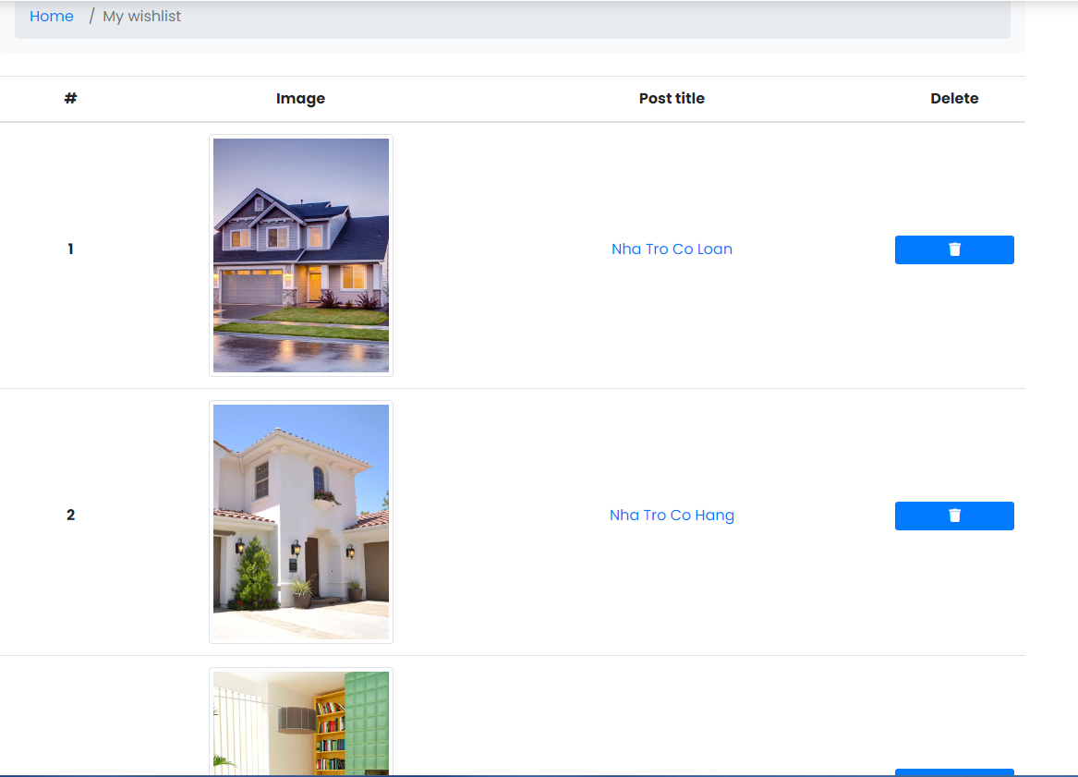

| **Field name** | **Field type** | **Description** |
| --- | --- | --- |
| # | Text | A number indicating order of property inside the wishlist |
| Image | Image | The thumbnail image of the post in the wishlist |
| Post title | Link | Text describes the name of property, click into the link to easily navigate to property |
| Delete | Button | Button to delete property from the wishlist |

##### Database Access

| **Table** | **CRUD** | **Description** |
| --- | --- | --- |
| Wishlist | R | Read wishlist table to get all properties belong to a specific userid |

1\ Get wishlist corresponding to user

SELECT * FROM Wishlist WHERE user_id = ?;

### 12.3 Remove from wishlist

##### UI Design

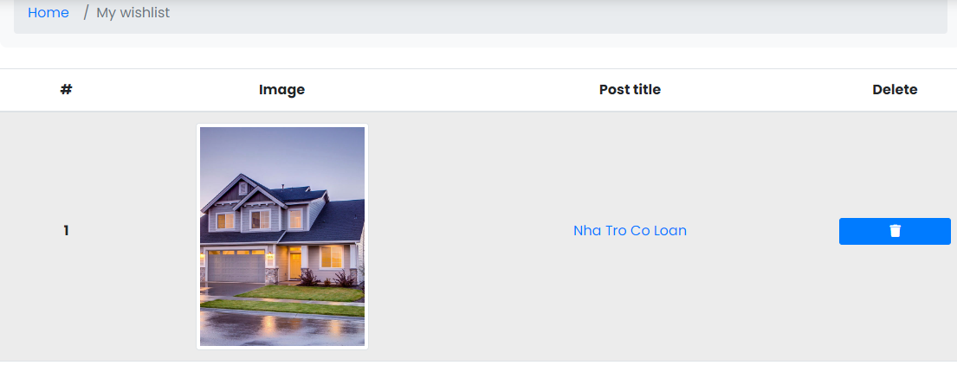

| **Field name** | **Field type** | **Description** |
| --- | --- | --- |
| # | Text | A number indicating order of property inside the wishlist |
| Post title | Link | Text describes the name of property, click into the link to easily navigate to property |
| Image | Image | The thumbnail image of the post in the wishlist |
| Delete | Button | Button to delete property from the wishlist |

##### Database Access

| **Table** | **CRUD** | **Description** |
| --- | --- | --- |
| Wishlist | R, D | Read wishlist table to get all properties belong to a specific userid |

1\ Get wishlist corresponding to user

SELECT * FROM Wishlist WHERE user_id = ?;

2\ Delete wishlist item

DELETE FROM [dbo].[Wishlist] WHERE id = ?;

## 13. Manage Order

### 13.1 View Order

##### UI Design

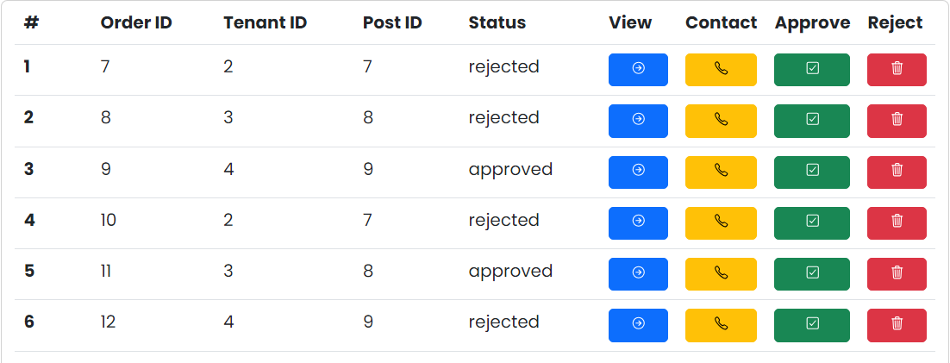

| **Field Name** | **Field Type** | **Description** |
| --- | --- | --- |
| ***Field Group Name*** | | |
| View Order | Table | Landlord can view all orders of the building they manages |

##### Database Access

| **Table** | **CRUD** | **Description** |
| --- | --- | --- |
| Order | R | The system will display all detailed orders |

***SQL Commands***

SELECT * FROM Orders WHERE order_id = <ORER_id_TARGET>

SELECT * FROM Orders WHERE tenant_id= <TENANT_id_TARGET>

SELECT * FROM Orders WHERE landlord_id= <LANDLORD_id_TARGET>

SELECT * FROM Orders WHERE status= <STATUS_VALUE_TARGET>

### 13.2 Manage Order

##### UI Design



| **Field Name** | **Field Type** | **Description** |
| --- | --- | --- |
| ***Field Group Name*** | | |
| Manage Order | Button | Landlord can approve or reject the room's order |

##### Database Access

| **Table** | **CRUD** | **Description** |
| --- | --- | --- |
| Order | U | The system will display all detailed orders |

***SQL Commands***

UPDATE Orders SET status = “approved” WHERE order_id = <ORER_id_TARGET>;

UPDATE Orders SET status = “rejected” WHERE order_id = <ORER_id_TARGET>;

### 13.3 System Access

#### a. View Order

This screen allow landlord to view all of the registered houses

Related use case:

##### UI Design

| **Field Name** | **Field Type** | **Description** |
| --- | --- | --- |
| ***Data table*** | | |
| View Order | Text | Landlord can view all orders of the building they manages |

##### Database Access

| **Table** | **CRUD** | **Description** |
| --- | --- | --- |
| Order | R | The system will display all detailed orders |

##### SQL Commands

SELECT * FROM Orders WHERE landlord_id = value

#### b. Manage Order

This screen allow landlord to reject or accept order

Related use case:

##### UI Design

| **Field Name** | **Field Type** | **Description** |
| --- | --- | --- |
| ***Field Group Name*** | | |
| Manage Order | Text | Landlord can approve or reject the room's order |
| Reject | Button | Landlord click to reject order |
| Approve | Button | Landlord click to approve order |

##### Database Access

| **Table** | **CRUD** | **Description** |
| --- | --- | --- |
| Order | U | The system will display all detailed orders |

##### SQL Commands

UPDATE Orders SET status = “approved” WHERE order_id = <ORDER_id_TARGET>;

UPDATE Orders SET status = “rejected” WHERE order_id = <ORDER_id_TARGET>;

## 14. Landlord Profile View

### 14.1 View landlord's profile

This screen allow landlord and admin to view tenant’s information

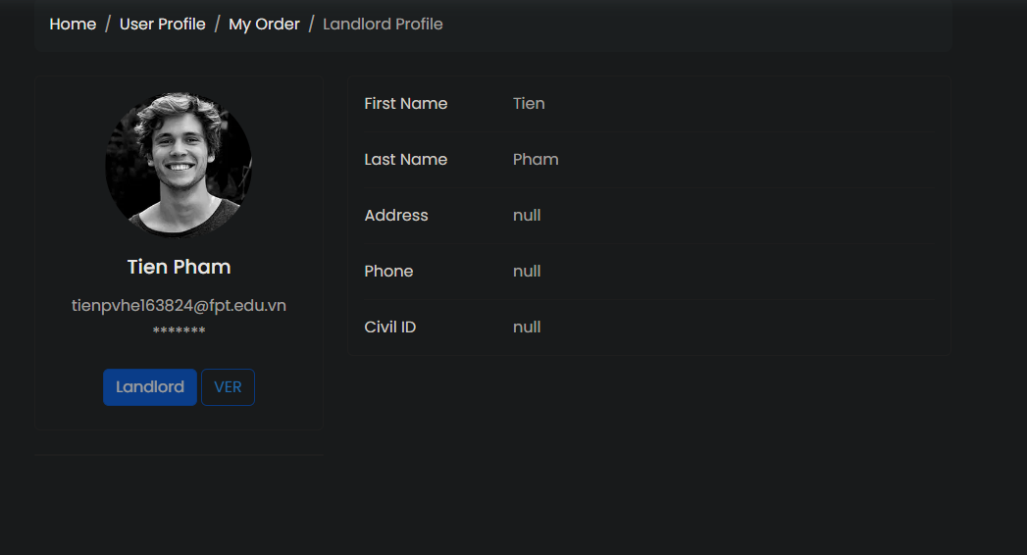

Related use case: UC20

##### UI Design

| **Field Name** | **Field Type** | **Description** |
| --- | --- | --- |
| ***Data table*** | | |
| Profile Picture | Image | Profile picture of tenant |
| Email | Text | Email address of tenant |
| Phone | Text | Phone number of tenant |

##### Database Access

| **Table** | **CRUD** | **Description** |
| --- | --- | --- |
| Tenant | R | The system will show tenant’s detail informations |

##### SQL Commands

select * from Tenant where id=?

## 15. System Report

### 15.1 Process report

##### UI Design

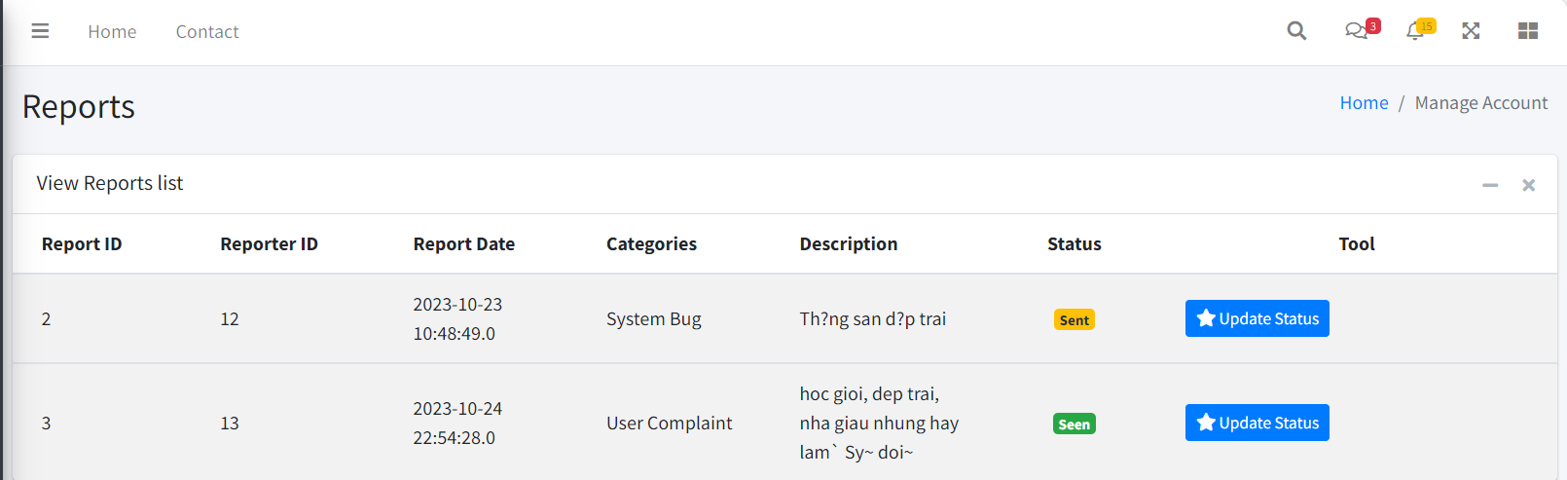

| **Field Name** | **Field Type** | **Description** |
| --- | --- | --- |
| ***Field Group Name*** | | |
| Report id | Text | Display Report id |
| Reporter id | Text | Displays the id of the person who reported |
| Report Date | Text | Displays the report date |
| Categories | Text | Displays the report type that the user selects |
| Description | Text | Displays the description the reporter wants to submit |
| Status | Text | Displays the status of the report |
| Update Status | Button | Change the status of the report from sent to viewed by admin |

##### 

##### Database Access

| **Table** | **CRUD** | **Description** |
| --- | --- | --- |
| Report | R | The system will display all reports in the data |

***SQL Commands***

select * from report

### 15.2 Send report

##### UI Design

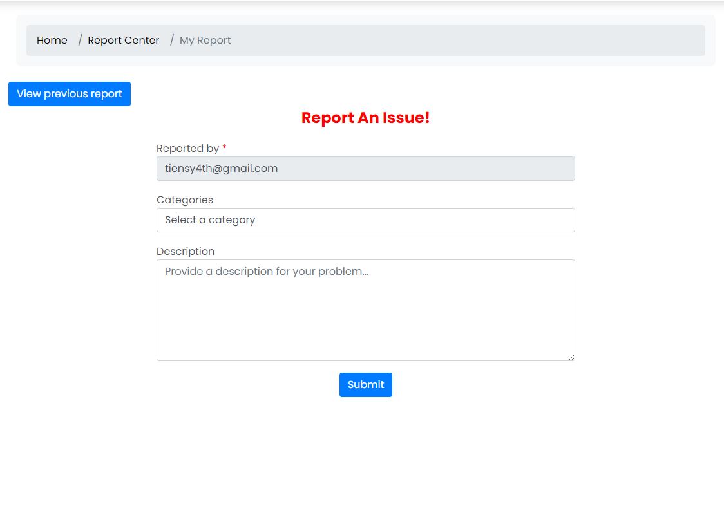

| **Field Name** | **Field Type** | **Description** |
| --- | --- | --- |
| ***Field Group Name*** | | |
| Reported By | Text | Display email of Reporter |
| Categories | Select | Select report categories user wants:User Complaint, Fraudulent Post, System Bug, Payment Problems, Legal, Others… |
| Reported Person( *Condition: category chosen is User Complaint)* | Text | Display email of Reported person. |
| Reported Post*( Condition: category chosen is Fraudulent Post)* | Text | Display the relative URL of the reported post. |
| Description | Text | Displays the description the reporter wants to submit |

##### 

##### Database Access

| **Table** | **CRUD** | **Description** |
| --- | --- | --- |
| Report | C | The system will insert report by user into database |

***SQL Commands***

"INSERT INTO [dbo].[Report]\n" ([reporter_id]\n" ,[property_id]\n" ,[reported_id]\n" ,[report_date]\n" ,[categories]\n" ,[description]\n" ,[status])\n" VALUES\n" (?\n" ,?\n" ,?\n" ,?\n"

,?\n" ,?\n" ,?)";

### 15.3 View report and cancel report

##### UI Design

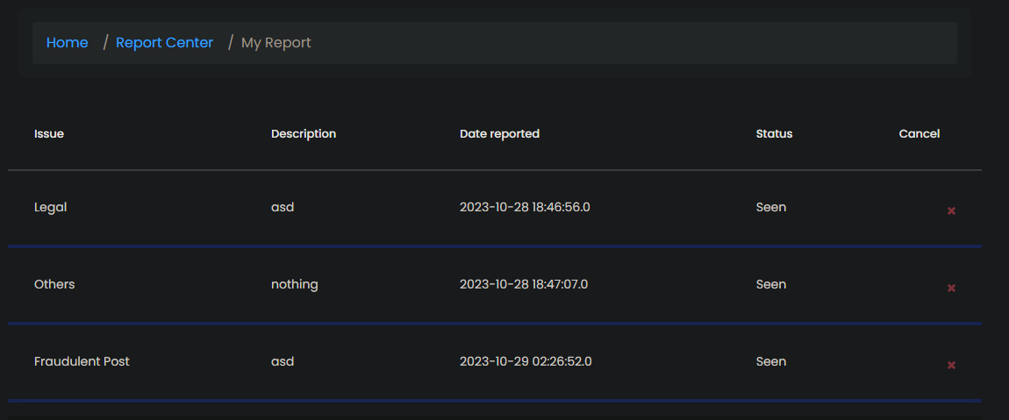

| **Field Name** | **Field Type** | **Description** |
| --- | --- | --- |
| ***Field Group Name*** | | |
| Issue | Text | Display the category of the report |
| Description | Text | Display the description that reporter reported |
| Date reported | Date | Display the day that reporter reported |
| Status | Text | Display status of reports |
| Cancel | Button | Cancel report, don’t sent to admin anymore |

##### 

##### Database Access

| **Table** | **CRUD** | **Description** |
| --- | --- | --- |
| Report | R | Users can see their reports |

***SQL Commands***

"SELECT * FROM Report WHERE reporter_id="+ Userid;

## 16. Post Management

### 16.1 Manage Post

##### UI Design

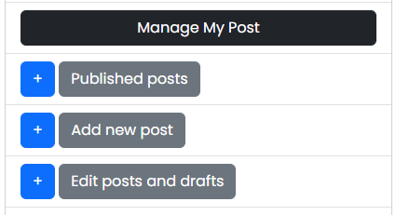

| **Field Name** | **Field Type** | **Description** |
| --- | --- | --- |
| ***Field Group Name*** | | |
| Manage Post | Text | Landlord can manage his rental posts |
| New Post | Text | Landlord can post promotional articles about his boarding house |
| Edit Post | Text |  |

##### Database Access

| **Table** | **CRUD** | **Description** |
| --- | --- | --- |
| Post | C | The system will create new rent house post |
| Post | R | The system will display all posts |
| Post | U | The system will update the post data again |
| Post | D | The system will delete the post according to the Landlord's wishes |

***SQL Commands***

SELECT * FROM Post WHERE landlord_id= ?

INSERT INTO Post (name, price, type, area, NumOfBedrooms, address, description, landlord_id, status, promotion_id, post_start_date, post_end_date) VALUES (value1, value2, value3, value4, value5, value6, value7, value8, value9, value10, value11, value12)

UPDATE Post SET name = value1, price = value2, type = value3, area = value4, NumOfBedrooms = value5, address = value6, description = value7,  
 WHERE id = idValue;

DELETE FROM Post WHERE post_id=value1

### 16.2 Pay Post

##### UI Design

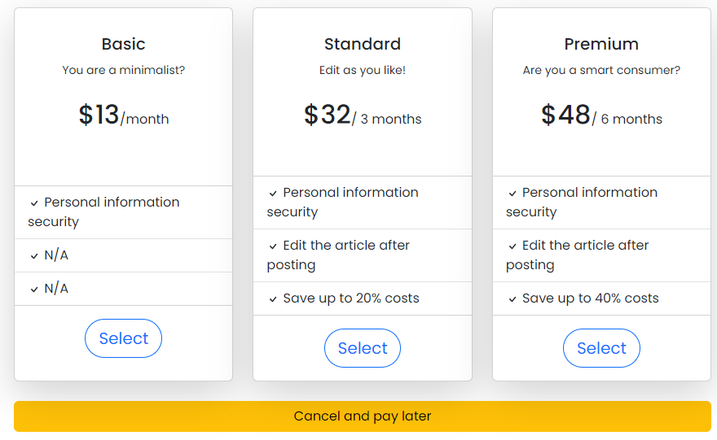

| **Field Name** | **Field Type** | **Description** |
| --- | --- | --- |
| ***Field Group Name*** | | |
| Post Type | Text | Landlord will have to pay the admin to be able to post articles on the website |
| Select | Button |  |

##### Database Access

| **Table** | **CRUD** | **Description** |
| --- | --- | --- |
| Report | C | The system will push a request to deposit points into the account from the landlord to the admin |

***SQL Commands***

INSERT INTO [dbo].[Report]   
([reporter_id] ,[property_id] ,[reported_id] ,[categories] ,[description] ,[status])   
VALUES   
(<reporter_id, int,> ,<property_id, int,> ,<reported_id, int,> ,<categories, nvarchar(100),> ,<description, text,> ,<status, nvarchar(20),>)

### 16.3 *Manage Post services*

#### a. Manage Post

This screen allow landlord and admin to create, edit or delete post

Related use case:

##### UI Design

| **Field Name** | **Field Type** | **Description** |
| --- | --- | --- |
| ***Field Group Name*** | | |
| Manage Post | Text | Landlord can manage his rental posts |
| New Post | Text | Landlord can post promotional articles about his boarding house |
| Edit Post | Text |  |

##### Database Access

| **Table** | **CRUD** | **Description** |
| --- | --- | --- |
| Post | C | The system will create new rent house post |
| Post | R | The system will display all posts |
| Post | U | The system will update the post data again |
| Post | D | The system will delete the post according to the Landlord's wishes |

##### SQL Commands

SELECT * FROM Post WHERE landlord_id= ?

INSERT INTO Post (name, price, type, area, NumOfBedrooms, address, description, landlord_id, status, promotion_id, post_start_date, post_end_date) VALUES (value1, value2, value3, value4, value5, value6, value7, value8, value9, value10, value11, value12)

UPDATE Post SET name = value1, price = value2, type = value3, area = value4, NumOfBedrooms = value5, address = value6, description = value7,  
 WHERE id = idValue;

DELETE FROM Post WHERE post_id=value1

#### b. Pay for Post

This screen allow landlord and admin to create, edit or delete post

Related use case:

##### UI Design

| **Field Name** | **Field Type** | **Description** |
| --- | --- | --- |
| ***Field Group Name*** | | |
| Pay Post | Text | Landlord will have to pay the admin to be able to post articles on the website |

##### Database Access

##### SQL Commands

## 17. User Account Manipulation

### 17.1 Add account

##### UI Design

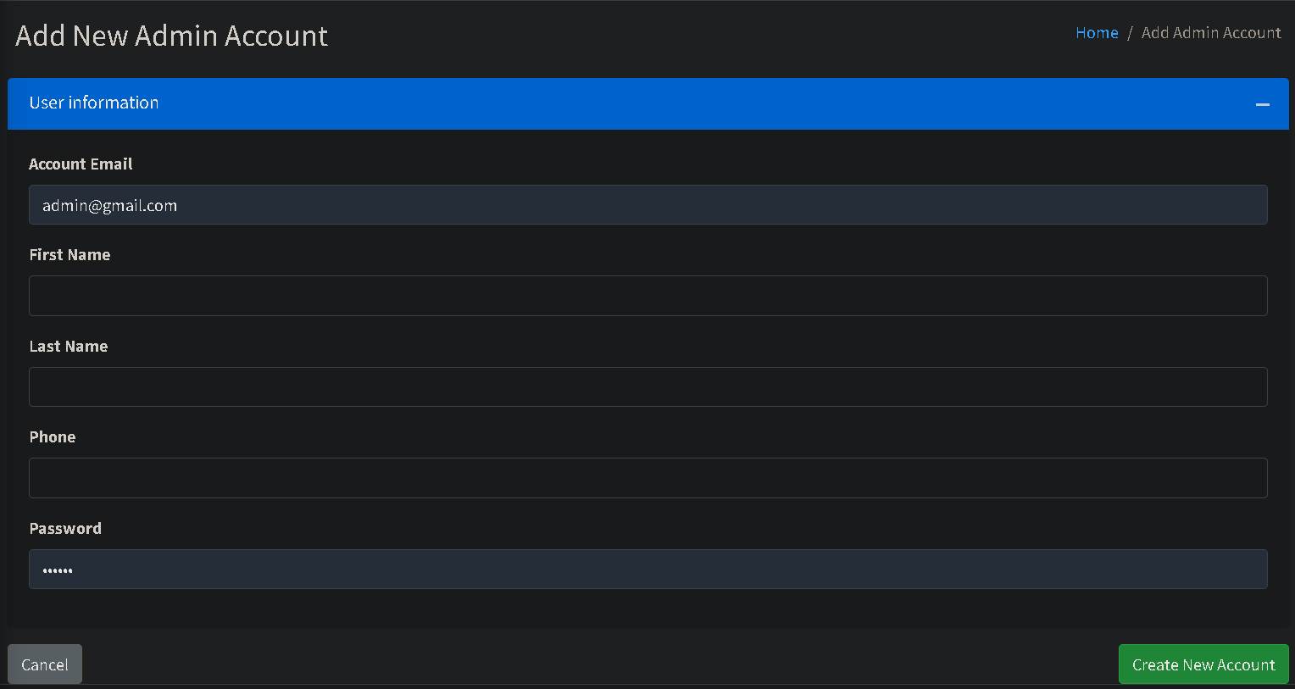

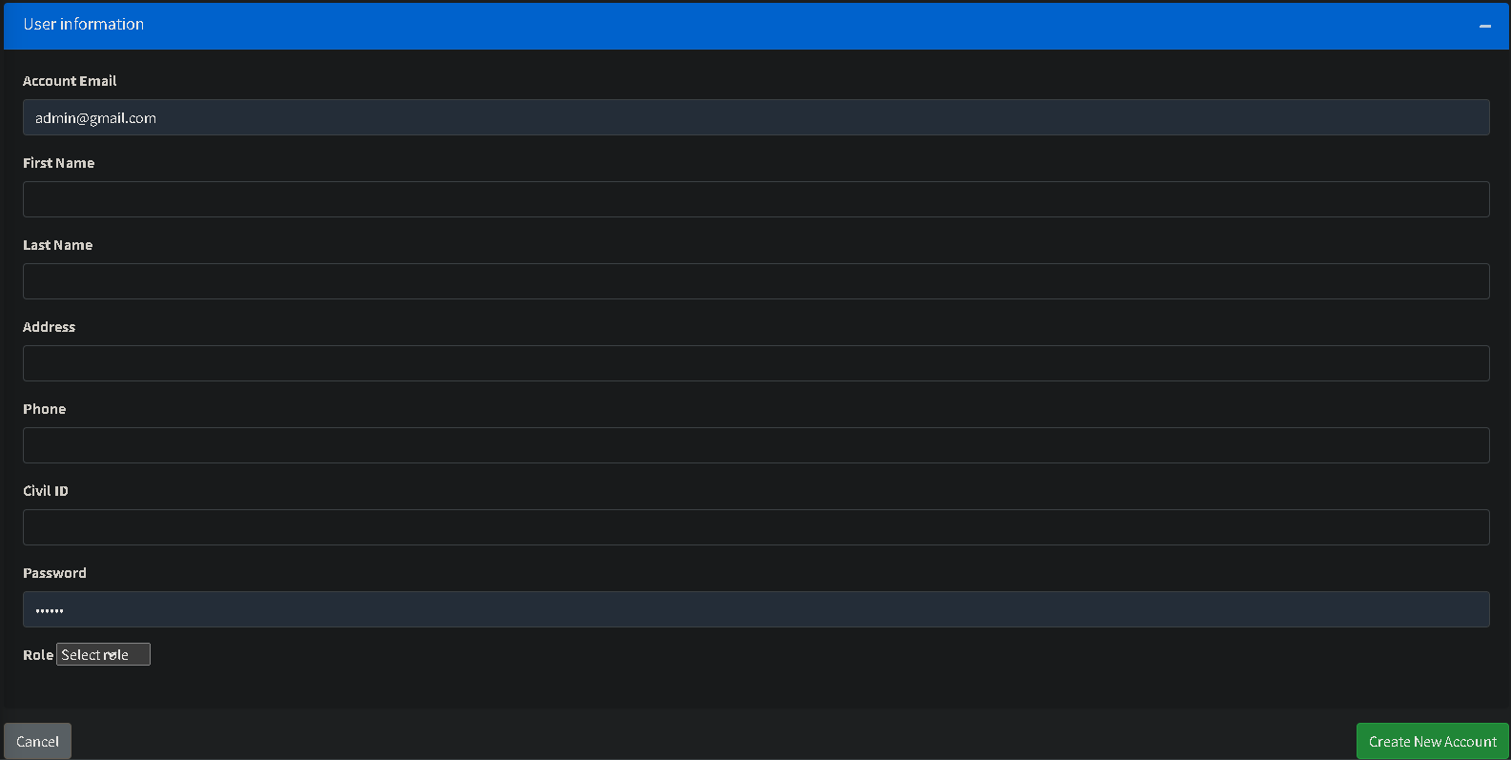

| **Field Name** | **Field Type** | **Description** |
| --- | --- | --- |
| ***Field Group Name*** | | |
| Account Email | Text | User’s email address |
| First Name | Text | User’s first name |
| Address | Text | User’s address |
| Last Name | Text | User’s last name |
| Phone | Text | User’s phone number |
| Civil id | Text | User’s civil id |
| Role | Select | User’s role when add tenant or landlord account |
| Password | Password | User’s password |
| Cancel | Button | Cancel add account |
| Create New Account | Button | Create a new account |

##### Database Access

| **Table** | **CRUD** | **Description** |
| --- | --- | --- |
| User | C | The system will add information to user account |
| Admin/Tenant /Landlord | C | The system will add information to corresponding table based on user role |

***SQL Commands***

1/ Add to User table

INSERT INTO Users(email, hashed_password, salt, role_id, status) VALUES (?,?,?,?,?);

2/ Add to Admin table

INSERT INTO Admin(id, first_name, last_name, phone) VALUES (?,?,?,?);

3/ Add to Tenant table

INSERT INTO Tenant (id, first_name, last_name, address, phone, civil_id) VALUES (?, ?, ?, ?, ?, ?);

4/ Add to Landlord table

INSERT INTO Landlord (id, first_name, last_name, address, phone, civil_id, account_points) VALUES (?, ?, ?, ?, ?, ?);

### 17.2 Update Account

##### UI Design

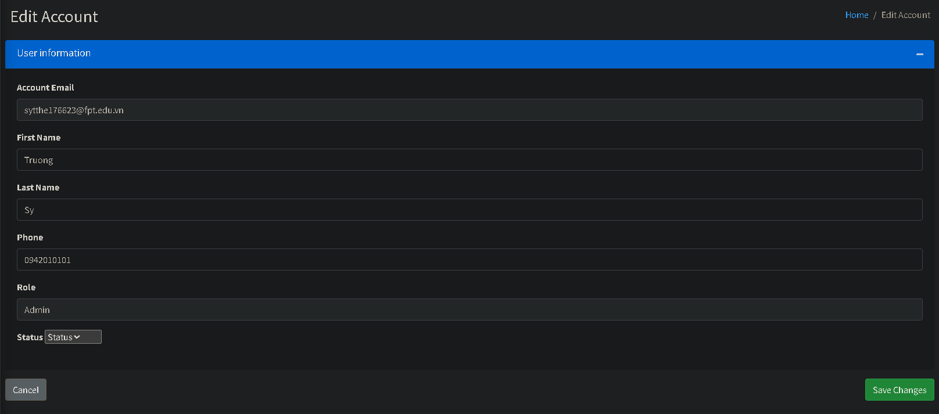

| **Field Name** | **Field Type** | **Description** |
| --- | --- | --- |
| ***Field Group Name*** | | |
| First Name | Text | User’s first name |
| Last Name | Text | User’s last name |
| Phone | Text | User’s phone number |
| Status | Select | User’s account status |

##### Database Access

| **Table** | **CRUD** | **Description** |
| --- | --- | --- |
| User | U | The system will update account status based on information entered |
| Admin/Tenant /Landlord | U | The system will update information to corresponding table based on user role |

***SQL Commands***

1/ Update to User table  
UPDATE Users SET [email] = ?,[hashed_password] = ?,[salt] = ?,[role_id] = ?,[status] = ? WHERE id = ?;

2/ Update to Admin table

UPDATE Admin SET [first_name] = ?,[last_name] = ?,[phone] = ? WHERE id = ?;

3/ Update to Tenant table

UPDATE Tenant SET [first_name] = ?,[last_name] = ?, [address] = ?, [phone] = ?, [civil_id] = ? WHERE id = ?;

4/ Update to Landlord table

UPDATE Landlord SET [first_name] = ?,[last_name] = ?,[address] = ?, [phone] = ?, [civil_id] = ? WHERE id = ?;

### 17.3 Disable Account

##### UI Design

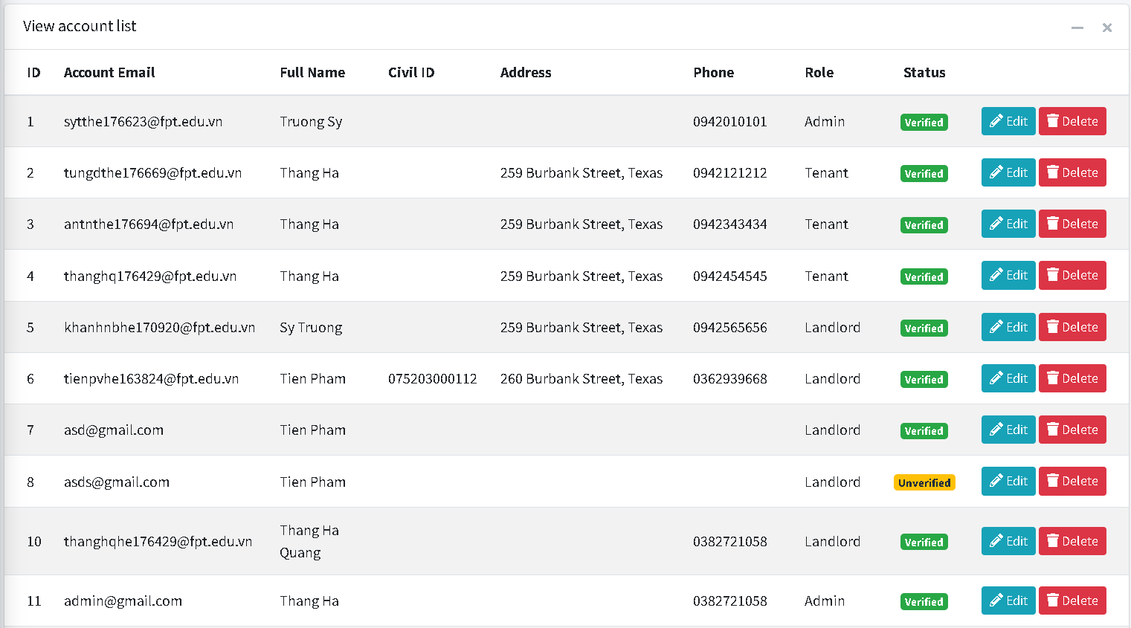

| **Field Name** | **Field Type** | **Description** |
| --- | --- | --- |
| ***Field Group Name*** | | |
| Delete | Button | Disable account |

##### Database Access

| **Table** | **CRUD** | **Description** |
| --- | --- | --- |
| Users | U | Update account status to Deleted |

***SQL Commands***

*Update Users set status = 'DEL' where id = ?*

### 17.4 Ban Account

##### UI Design

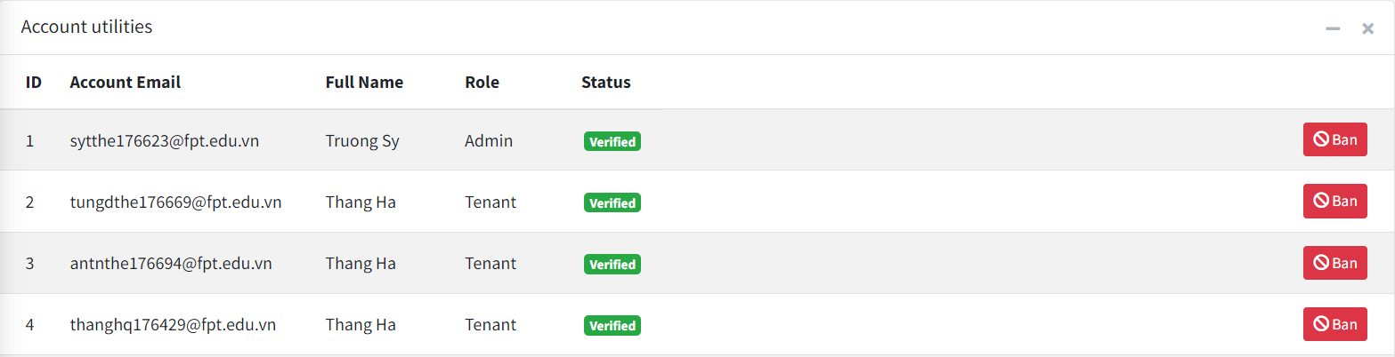

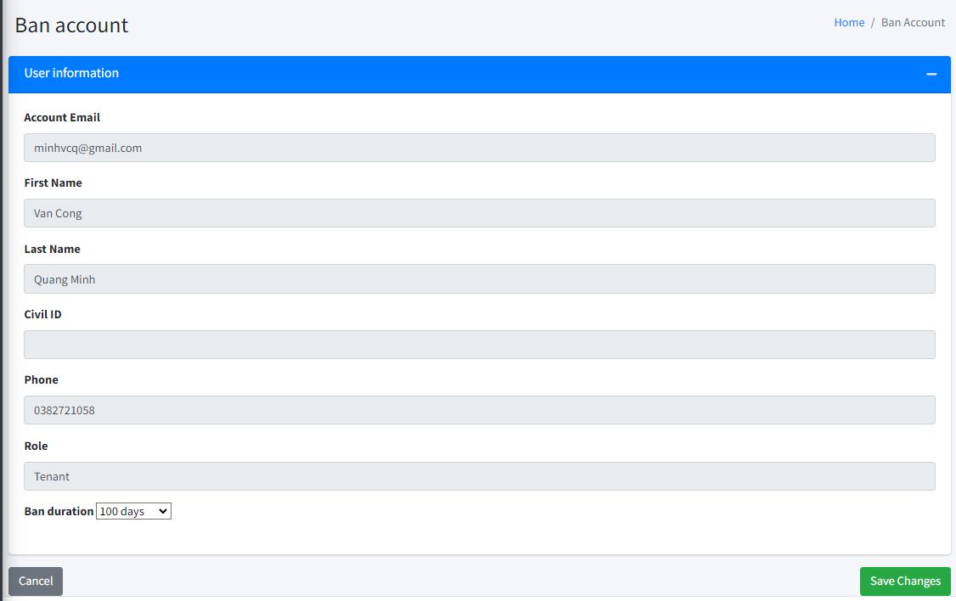

| **Field Name** | **Field Type** | **Description** |
| --- | --- | --- |
| ***Field Group Name*** | | |
| Ban | Button | Click to choose ban an account |
| Account Email | Text (readonly) | Email of banned account |
| First Name | Text (readonly) | First name of banned account |
| Last Name | Text (readonly) | Last name of banned account |
| Civil id | Text (readonly) | Civil id of banned account |
| Phone | Text (readonly) | Phone number of banned account |
| Role | Text (readonly) | Role of banned account |
| Ban duration | Combo box | Durations of banning |
| Cancel | Button | Cancel ban operation |
| Save Changes | Button | Confirm ban operation |

##### Database Access

| **Table** | **CRUD** | **Description** |
| --- | --- | --- |
| User_banned | C, R, U | Add the account of the user who has been banned to the database. Check if a banned record exists before. |
| Users | R, U | Check for account existence, update status |

***SQL Commands***

1\ Check for account existence

SELECT * FROM Users WHERE id = ?;

2\ Check for ban record

SELECT * FROM User_banned WHERE id = ?;

3\ Add banned record to User_banned

INSERT INTO [dbo].[User_banned]([id],[email],[ban_start_date],[ban_end_date],[status]) VALUES (?,?,?,?,?);";

4\ Update banned record

UPDATE [dbo].[User_banned] SET [email] = ?,[ban_start_date] = ?,[ban_end_date] = ?,[status] = ? WHERE id = ?;

5\ Update user’s status

UPDATE [dbo].[Users] SET [status] = ? WHERE id = ?;

### 17.5 Unban Account

##### UI Design



| **Field Name** | **Field Type** | **Description** |
| --- | --- | --- |
| ***Field Group Name*** | | |
| Un-ban | Button | Unban an account |

##### Database Access

| **Table** | **CRUD** | **Description** |
| --- | --- | --- |
| User_banned | U | Update user’s status from Ban to Unban |
| Users | U |  |

***SQL Commands***

1\ Check for existence of user

SELECT * FROM Users WHERE id = ?;

2\ Check ban status of user

SELECT * FROM User_banned WHERE id = ?;

3\ Update banned record

UPDATE [dbo].[User_banned] SET [email] = ?,[ban_start_date] = ?,[ban_end_date] = ?,[status] = ? WHERE id = ?;

4\ Update user status

UPDATE [dbo].[Users] SET [email] = ?,[hashed_password] = ?,[salt] = ?,[role_id] = ?,[status] = ? WHERE id = ?;

### 17.6. View all account

**UI Design**

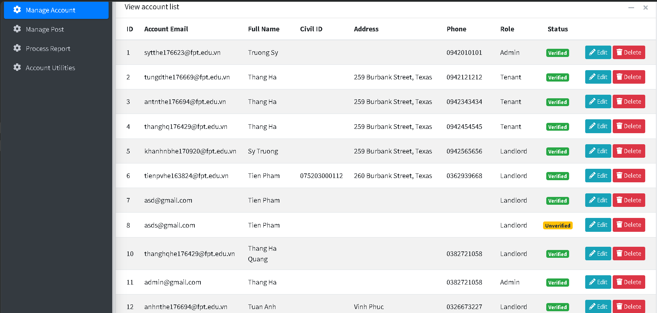

| **Field Name** | **Field Type** | **Description** |
| --- | --- | --- |
| ***Field Group Name*** | | |
| id | Text | Display id of the account |
| Account Email | Text | Display email of the account |
| Full Name | Text | Display full name of the account owner |
| Civil id | Text | Display civil id of the the account owner (available for Tenant and Landlord) |
| Address | Text | Display address of the account owner (available for Tenant and Landlord) |
| Phone | Text | Display phone of the the account owner |
| Role | Text | Display the account role |
| Status | Text | Display status of the the account |
| Edit | Button | Click to edit the corresponding account |
| Delete | Button | Click to disable the corresponding account |

##### Database Access

| **Table** | **CRUD** | **Description** |
| --- | --- | --- |
| Users | R | Read Users table to get all accounts |

***SQL Commands***

SELECT * FROM Users;

## 18. Point Management

### 18.1 Add Point to landlord

##### UI Design

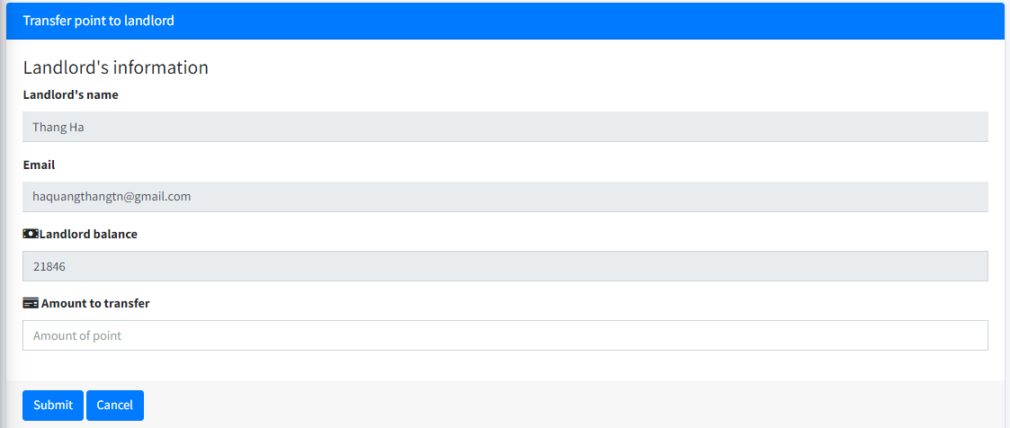

| **Field name** | **Field type** | **Description** |
| --- | --- | --- |
| Landlord’s name | Text | Display landlord’s name |
| Email | Text | Display landlord’s email |
| Landlord balance | Number | Display current landlord point |
| Amount to transfer | Number | Amount of point to add to landlord account |
| Submit | Button | Button to submit point transfer |
| Cancel | Button | Button to return back to account utilities page |

**Database Access**

| **Table** | **CRUD** | **Description** |
| --- | --- | --- |
| Users | R | Read user table checking for logging in status |
| Landlord | R, U | Get landlord object corresponding to user id, and then update landlord account |
| Transactions | C | Create transaction record |

1\ Get user object

SELECT * FROM Users WHERE id = ?;

2\ Get landlord object

SELECT * FROM Landlord WHERE id = ?;

3\ Update landlord account

UPDATE [Landlord] SET [first_name] = ?, [last_name] = ?, [address] = ?, [phone] = ?, [civil_id] = ?, [account_points] = ? WHERE id = ?;

4\ Create transaction records

INSERT INTO [Transactions] ([amount], [payer_id], [receiver_id], [type], [transaction_date], [post_id]) VALUES (?,?,?,?,?,?);

## 

### 18.2 View transaction history

##### UI Design

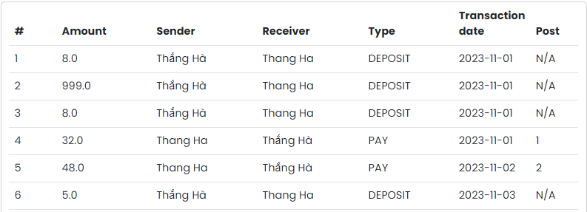

| **Field Name** | **Field Type** | **Description** |
| --- | --- | --- |
| # | Number (readonly) | Order of the transaction in the list |
| Amount | Number (readonly) | Amount of point in the transaction |
| Sender | Text (readonly) | Name of sender |
| Receiver | Text (readonly) | Name of receiver |
| Type | Text | Type of transaction taken |
| Transaction date | Date | Date the transaction taken |
| Post | Number | id of the post |

##### Database Access

| **Table** | **CRUD** | **Description** |
| --- | --- | --- |
| Landlord | R, U | The system will update point of the landlord |

##### SQL Commands

SELECT [transaction_id] ,[amount] ,[payer_id] ,[type] ,[transaction_date] ,[post_id]   
FROM [dbo].[Transactions]

## 19. Tenant Profile View

### 19.1 View tenant profile

##### UI Design

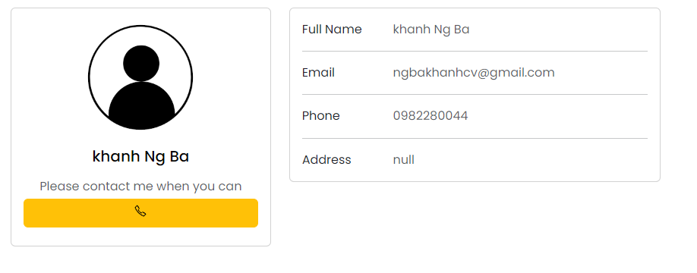

##### Database Access

| **Field Name** | **Field Type** | **Description** |
| --- | --- | --- |
| Full Name | Text(Readonly) | Display tenant full name |
| Email | Text(Readonly) | Display tenant email |
| Phone | Text(Readonly) | Display tenant phone |
| Address | Text(Readonly) | Display tenant address |

##### SQL Commands

SELECT * FROM Tenant WHERE tenant_id=value1

## 20. Promotion Management

### 20.1 Create a promotion

##### UI Design

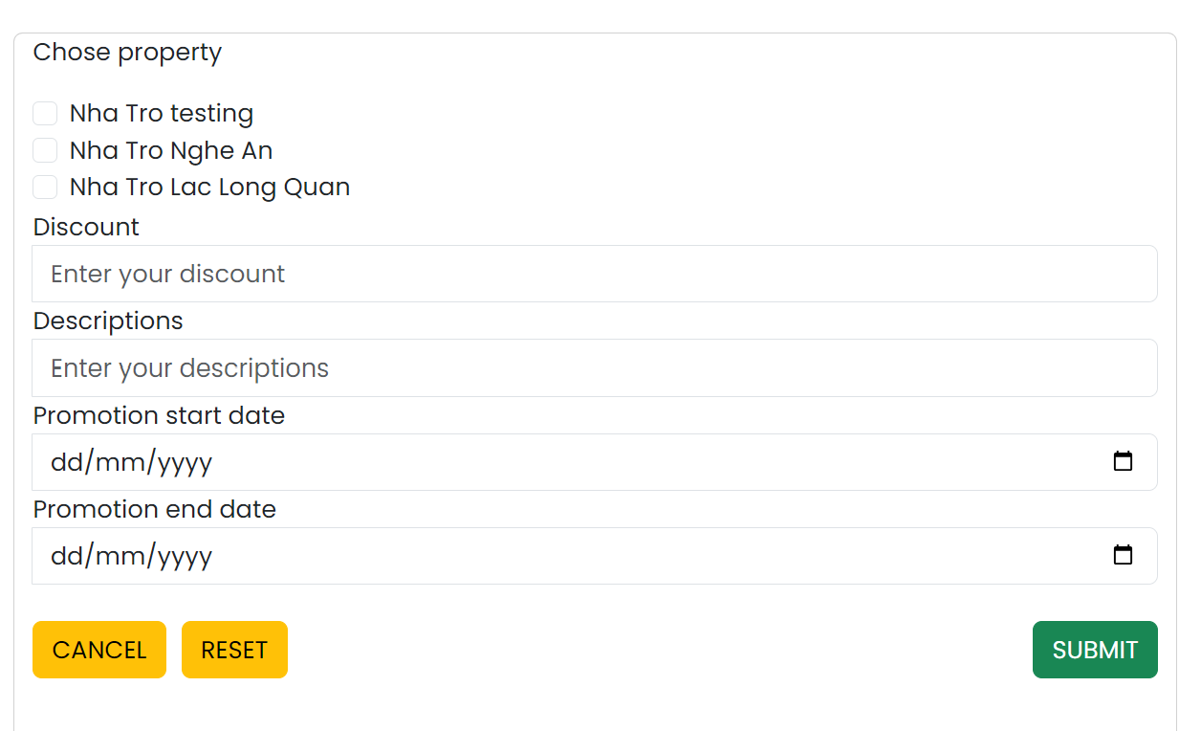

| **Field Name** | **Field Type** | **Description** |
| --- | --- | --- |
| Property | Check box | Landlord can offer promotions for his boarding house |
| Discount | Number | Landlord enter discount percent for the promotion |
| Descriptions | Text | Landlord enter promotion description for promotion |
| Promotion start date | Date | Landlord enter start date for the promotion |
| Promotion end date | Date | Landlord enter end date for the promotion |
| Submit | Button | Send data to add to web’s database |
| Cancel | Button | Return to promotion manage |
| Reset | Button | Clear all field |

##### Database Access

| **Table** | **CRUD** | **Description** |
| --- | --- | --- |
| Post ( promotion ) | C | The system will add data to the promotion post as requested by the landlord |

##### SQL Commands

INSERT INTO Promotion (discount,description,promotion_start_date,promotion_end_date) VALUES(value1,value2,value3,value4)

### 20.2 Edit promotion

##### UI Design

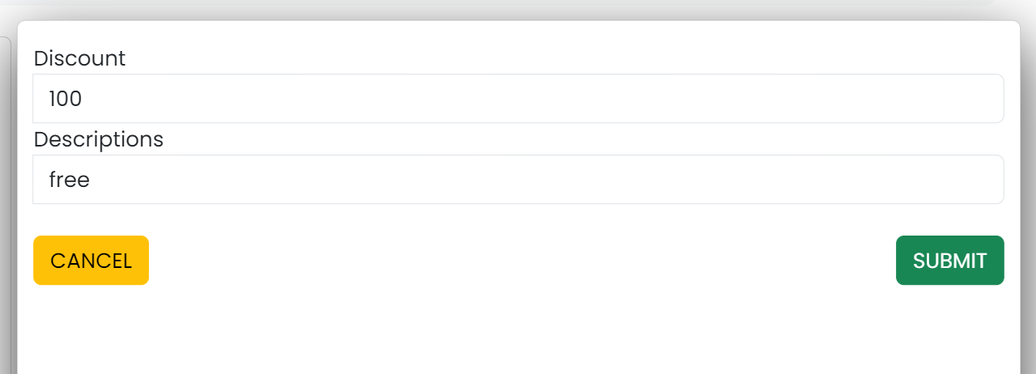

| **Field Name** | **Field Type** | **Description** |
| --- | --- | --- |
| Discount | Number | Landlord can edit discount percent |
| Descriptions | Text | Landlord can edit descriptions |
| Submit | Button | Send data to add to web’s database |
| Cancel | Button | Return to promotion manage |

##### Database Access

| **Table** | **CRUD** | **Description** |
| --- | --- | --- |
| Post ( promotion ) | U | The system will update data to the promotion post as requested by the landlord |

##### SQL Commands

UPDATE Promotion SET discount=value1,descriptions=value2 WHERE promotion_id=value3

### 20.3 Remove promotion

##### UI Design

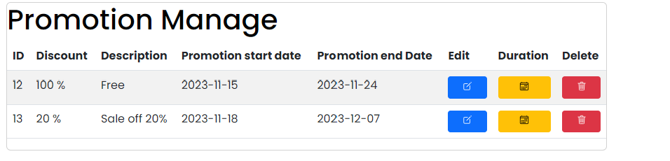

| **Field Name** | **Field Type** | **Description** |
| --- | --- | --- |
| ***Field Group Name*** | | |
| Delete | Button | Landlord can remove previously added promotions |

##### Database Access

| **Table** | **CRUD** | **Description** |
| --- | --- | --- |
| Post ( promotion ) | D | The system will remove promotion post as requested by the landlord |

##### SQL Commands

DELETE FROM Promotion WHERE promotion_id=value1

### 20.4 Promotion View

##### UI Design

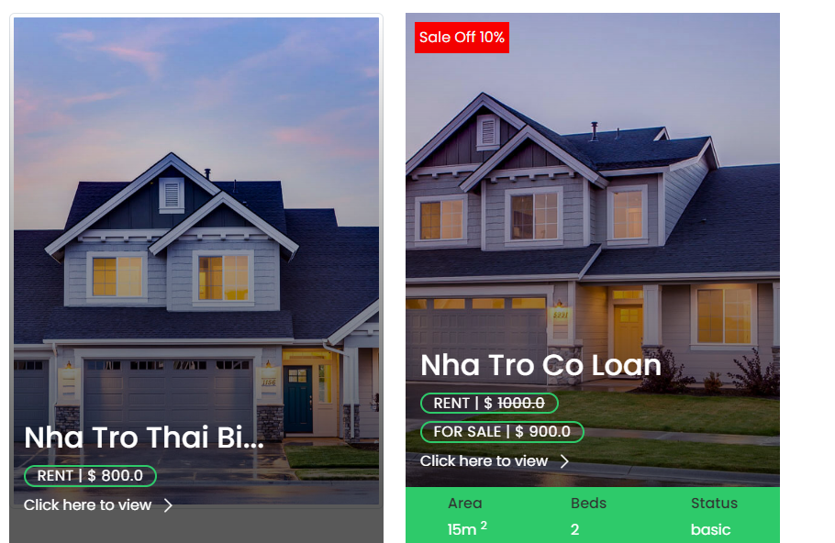

| **Field Name** | **Field Type** | **Description** |
| --- | --- | --- |
| Click here to view | Button | Display house detail |

##### Database Access

| **Table** | **CRUD** | **Description** |
| --- | --- | --- |
| Promotions | R | The system will display landlord promotion |

##### SQL Commands

SELECT discount FROM Promotions WHERE promotion_id = value1

### 20.5 Set promotion duration

##### UI Design

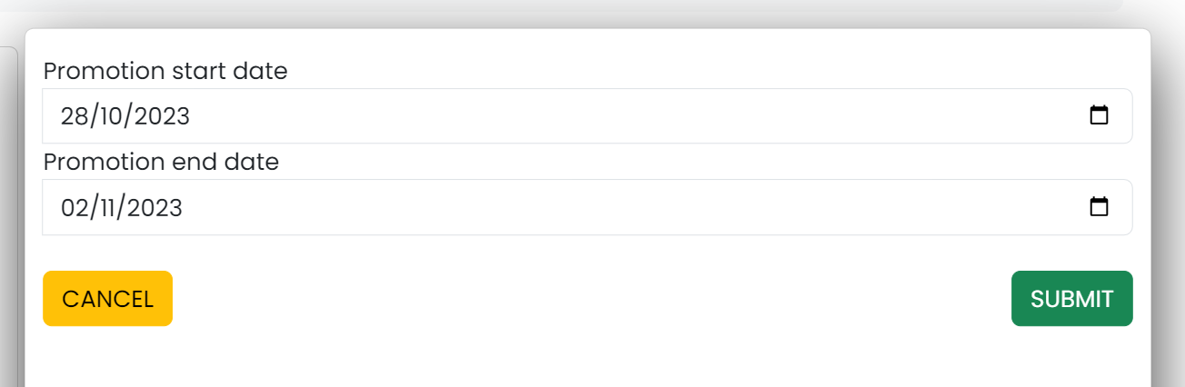

| **Field Name** | **Field Type** | **Description** |
| --- | --- | --- |
| Promotion start date | Date | Landlord can edit promotion’s start date |
| Promotion end date | Date | Landlord can edit promotion’s end date |
| Submit | Button | Send data to add to web’s database |
| Cancel | Button | Return to promotion manage |

##### Database Access

| **Table** | **CRUD** | **Description** |
| --- | --- | --- |
| Post ( promotion ) | U | The system will update data to the promotion post as requested by the landlord |

##### SQL Commands

UPDATE Promotion SET promotion_start_date=value1 , promotion_end_date=value2 WHERE promotion_id=value3

# IV. Appendix

## 1. Assumptions & Dependencies

AS-1: The system cannot replace all the processes between tenant, landlord and admin.

AS-2: Information about tenants and landlords, such as account information, landlord posts and tenant orders are available to admin.

AS-3: Points in the landlord's account represent the transaction between landlord and admin.

AS-4: The system is made for Vietnamese people only (Information such as phone number, civil id are in Vietnamese format)

AS-5: Landlord’s post will always have at least 2 pictures of house images to give tenants a better look at their houses.

DE-1: The success of the system depends on the accurate and timely input of data.

DE-2: The system’s effectiveness relies on the users’ ability to navigate and use its features.

DE-3: The system is dependent on the technological infrastructure, including reliable internet connectivity and appropriate hardware.

## 2. Limitations & Exclusions

Limitations :

* The system can be quite costly, especially for small property owners.
* Training a tenant or agent to use the system can consume a lot of time.
* If the owner or admin does not select a software that suits the renting out of the property, it can be very time-consuming.
* Since the data is manually recorded and managed, it is hard to keep track of the data while it is paper-based.
* Lack of a computerized and more sophisticated way for the landlords to manage the information about their houses and tenants.
* The system currently does not have a payment gate that connects directly to the bank account, so that the landlord must have to transfer money to the admin manually.
* The system now has very limited ways to determine the status of a Post (corresponding to a house) as available for renting, or it has been occupied.
* The system is unable to automatically check for post status

Exclusions :

* The system may not include features that are specific to certain types of rental properties or unique rental agreements.
* It may not integrate with other systems or platforms that a property owner uses.
* It may not offer customer support or regular updates to improve functionality and address issues.
* The house rental system is just an intermediary, connecting tenants and lessors. The system is not responsible for the legality or contract between the two parties.

## 3. Business Rules

| **id** | **Category** | **Rule Definition** |
| --- | --- | --- |
| BR-01 | Facts | Accounts’ email must be valid (in the correct format, exist email address). |
| BR-02 | Facts | The system must validate the user’s password during login. The password should be encrypted and stored securely. |
| BR-03 | Facts | Only active users should be allowed to log in. Users with banned or deactivated accounts should not be able to log in. |
| BR-04 | Facts | Account’s password must not be stored as a string sequence. Instead it must be hashed using a secure hash algorithm SHA-512. |
| BR-05 | Facts | Users must be logged in to log out. |
| BR-06 | Facts | Cannot register with an email that has already been registered as the same role, or when there is another activated account using the same email. |
| BR-07 | Constraints | When registering or changing the password, the user must enter the new password twice. |
| BR-08 | Inferences | If a user registered successfully, they must have an inactive account with code sent to email, when user follow the link sent to the mail, that account will be activated |
| BR-09 | Inferences | Ìf a user does not perform password changes within 10 minutes after the email is sent, then no changes will be applied. |
| BR-10 | Facts | The system should track all payments made by landlords, including the date of payment and the amount paid. |
| BR-11 | Facts | When a landlord approves a booking request from a tenant, the status of a Post will be modified from Available to Occupied to fit the changes. |
| BR-12 | Action enabler | Every attempt of changing or deleting will result in a prompt for confirmation. |
| BR-13 | Facts | The system must maintain a record of all orders made by tenants, including the tenant who ordered, the landlord whose post is ordered, and status of order. |
| BR-14 | Facts | The system must maintain a record of all tenants, including their contact information, rental history, and payment status. |
| BR-15 | Facts | The system must display the right posts based on the attribute searched. |
| BR-16 | Facts | When changing password, the new password must not be the same as the current password. |
| BR-17 | Constraints | Guests can only view the homepage and as role Guests. |
| BR-18 | Action enabler | When a guest proceeds to book a room, they are prompted to log in as a tenant. |
| BR-19 | Constraints | To process the order list, user must have the Landlord role |
| BR-20 | Constraints | Landlords can only process the orders from their posts. |
| BR-21 | Action enabler | If a user’s comments use bad words, they will be warned and their comments will not be accepted. |
| BR-22 | Action enabler | If a user makes too many comments on a post (spamming), their account will be banned. |
| BR-23 | Constraints | To approve/ reject orders, the user must log in with landlord roles. |
| BR-24 | Constraints | Landlords can only approve or reject orders that have not been processed yet. |
| BR-25 | Constraints | The operation of approve or reject orders can only be done once. |
| BR-26 | Constraints | Passwords used to login or register must contain at least 6 characters, 1 uppercase symbol, 1 lowercase symbol and 1 special symbol. |

### 

### 

### 

### 

## 